CHAPTER 1

1. INTRODUCTION
1.1 PROJECT INTRODUCTION
This Web Application mainly deals with the parking slots in the buildings like clubs, hotels, malls and many more. In this Web Application we can access the information of parking slots in the malls where is free. By finding the empty space the user is able to block the slot. This application also provides information about the user like Car No and mobile number the administration will able to notify the user if there is any problem. After selecting the empty space in the parking slot the user is able to pay the amount and confirm his/her booking.
The alternative is to find a car parking with empty parking space to allot to the person wishing to park the car.The automatic management of parking lots by accurate monitoring and providing service to the customers and administrators is provided by such emerging services. Currently, most of the existing car parking system are manually managed and a little inefficient.In Urban areas, where number of vehicles is higher as compared to the availability of parking spaces, a lot of time being wasted in searching for parking locations. Shopping malls, sports stadiums and similar venue often feature parking lots of immense area.
A web application is an application program that is stored on a remote server and delivers over the internet through a browser interface. Web services are web apps by definition and many, although not all website contain web apps. Web application helps organization reach new customers and let them know about the organization and services provided by it. With its help, it is easier to maintain a proper communication channel between potential customers and business organization.
Hence online booking parking system is a proposed method that users can reserve their parking places using web.

CHAPTER 2

2.WORKING ENVIRONMENT
2.1 HARDWARE REQUIREMENT
- Hard Disk : 500GB and Above
- RAM : 4GB and Above
- Processor : I3 and Above
  - SOFTWARE REQUIREMENT
- VisualStudio Code
- Spring Tool Suit
- MySQL Server
- Apache Tomact Server
2.3 SYSTEM SOFTWARE
Front-End
  - HTML + CSS
  - AngularJS
  - Bootstrap
Middle Ware
  - Spring Boot
  - Spring MVC
  - Spring Web
  - Spring Hibernate
Back-End
  - MySQL

CHAPTER 3

3.SYSTEM ANALYSIS
3.1 FEASIBILITY STUDY
3.1.1 Technical Feasibility:
Technical feasibility includes the software’s and hardware that are needed to develop the system. Software’s and hardware have to be chosen according to the client requirements. We have to be very clear about what are the technologies that are to be required for the development of the new system.
3.1.2 Economical Feasibility:
Economic feasibility attempts to weigh the costs of developing and implementing a new system. To develop the project from top to bottom, the estimated cost will comes under this feasibility. It defines whether the client is able to pay the estimated cost or not. If the client is unable to spend then the software’s have to be changed.
3.1.3 Operational Feasibility:
Proposed system is beneficial only if it will meet the organizations operating requirements. The current business operations are considered. This test of feasibility asks if the system will work when it is developed and installed. Here are questions that will help test the operational feasibility of a project.
3.2 EXISTING SYSTEM
We already have many Car Parking management systems which can provide services for the users only with the help of RFID tags or Sensors. In the Existing System, by using the electrical equipment only we can find the empty slot by an indication method. We can only identify the free slot but we can't book the slot before.
3.3 DRAWBACKS OF EXISTING SYSTEM
The following are the disadvantages of the existing system
- It is difficult to maintain the whole database (images of the parking space).
- Users have to spend 1-2 minutes for booking the slot (only registered).
3.4 PROPOSED SYSTEM
- The purpose of this project is to ease the process of parking through the web application.
- In this we mainly concentrate on parking slot in the building and the user is able to block the slot before entering into the building.
- The web application is designed for client side. It contains only user friendly options.
3.5 BENEFITS OF PROPOSED SYSTEM
- A fast and efficient service to the user regarding to the
- Searching process is an easy task.
- Selecting and booking a slot is also an easy process.
- Saves lot of time while searching a free slot in the building and even may avoid the minor accidents.
3.6 SCOPE OF THE PROJECT
A detailed study of the existing system is necessary. The functions of the system, requirements for the users, structure of the current system is made through the system study.
The problems faced in the current system are found and solution pertaining to it is done in the system study.
Users can get learn about parking areas for particular locations,
It saves user time in search of parking space available in such a long parking area.
It excludes the need of human efforts for managing parking spaces.

CHAPTER 4

4.SYSTEM DESIGN
4.1 DATA FLOW DIAGRAM
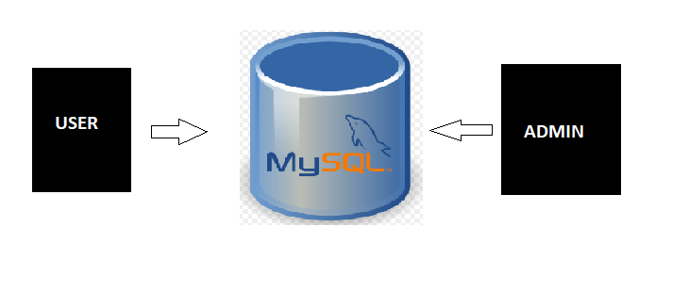
FIGURE 4.1 DATA FLOW DIAGRAM
4.2 USE CASE DIAGRAM
A use case diagram in the Unified Modeling Language (UML) is a type of behavioral diagram defined by and created from a Use-case analysis. Its purpose is to present a graphical overview of the functionality provided by a system in terms of actors, their goals (represented as use cases), and any dependencies between those use cases. The main purpose of a use case diagram is to show what system functions are performed for which actor. Roles of the actors in the system can be depicted.

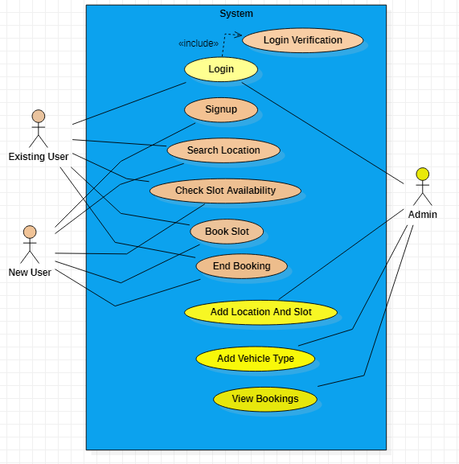
FIGURE 4.2 USE CASE DIAGRAM

4.3 CLASS DIAGRAM
This diagram consists of the following classes, attributes and their operations.
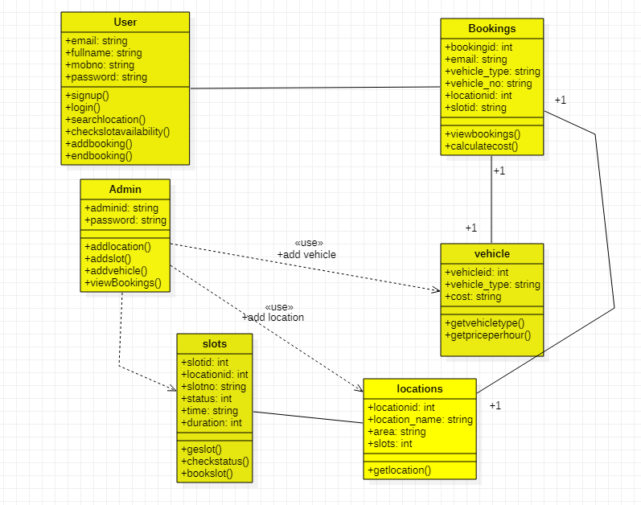
FIGURE 4.3 CLASS DIAGRAM
4.4 Activity Diagram
An activity diagram is a behavioral diagram i.e. it depicts the behavior of a system. An activity diagram portrays the control flow from a start point to a finish point showing the various decision paths that exist while the activity is being executed.
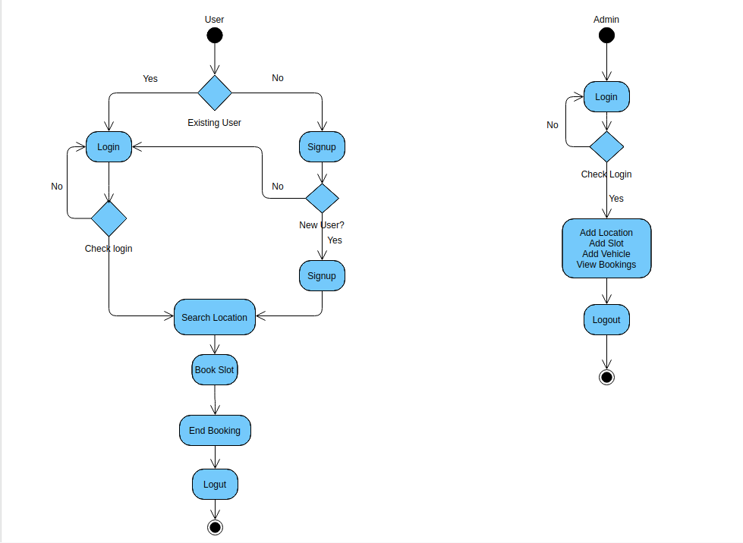
FIGURE 4.4 – ACTIVITY DIAGRAM

4.5 ARCHITECTURE DIAGRAM
A simple architecture diagram (UML) helps system designers and developers visualize the high-level structure of their system or application to ensure it meets their users' needs. It can also help describe patterns that are used throughout the design. Similar to a blueprint, teams can use our simple architecture diagram template as a guide to easily discuss and improve their products.
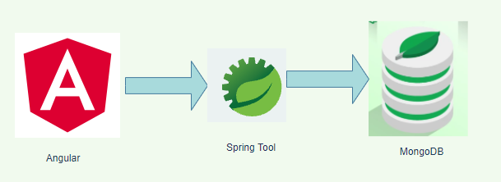
FIGURE 4.5 - ARCHITECTURE DIAGRAM
4.6 DATABASE DESIGN
TABLE 1: Admin
ATTRIBUTES | DATATYPE | CONSTRAINTS
Adminid | Int(11) | NOT NULL
Password | Varchar(200) | NULL

TABLE 2: Booking
ATTRIBUTES | DATATYPE | CONSTRAINTS | KEY
Bookingid | Int(11) | NOT NULL | PRIMARY KEY
Email | Varchar(200) | NULL | NOT PRIMARY KEY
Vehicle_type | Varchar(200) | NULL | NOT PRIMARY KEY
Vehicle_no | Varchar(200) | NULL | NOT PRIMARY KEY
Location | Varchar(200) | NULL | NOT PRIMARY KEY
Slotid | Varchar(200) | NULL | NOT PRIMARY KEY
Date | Int(11) | NULL | NOT PRIMARY KEY
Time | Int(11) | NULL | NOT PRIMARY KEY
Duration | Varchar(200) | NULL | NOT PRIMARY KEY
Cost | Int(11) | NULL | NOT PRIMARY KEY
Paid | Varchar(200) | NULL | NOT PRIMARY KEY

TABLE 3: USERS
ATTRIBUTES | DATATYPE | CONSTRAINTS | KEY
Email | Varchar(200) | NOT NULL | PRIMARY KEY
Fullname | Varchar(200) | NULL | NOT PRIMARY KEY
Mobno | Int(11) | NULL | NOT PRIMARY KEY
Password | Varchar (200) | NULL | NOT PRIMARY KEY

TABLE 4: SLOTS
SLOTID | LOCATIONID | SLOTNO | STATUS | TIME | DURATION
1slot1 | 1 | Slot 1 | 0 | 0 | 0
1slot2 | 1 | Slot 2 | 0 | 0 | 0
1slot3 | 1 | Slot 3 | 0 | 0 | 0
27slot1 | 27 | Slot 1 | 0 | 0 | 0
27slot2 | 27 | Slot 2 | 0 | 0 | 0
28slot1 | 28 | Slot 1 | 0 | 0 | 0
2slot2 | 2 | Slot 2 | 0 | 0 | 0
34slot1 | 34 | Slot 1 | 0 | 0 | 0

TABLE 5: LOCATIONS
LOCATIONID | LACATION_NAME | AREA | SLOTS
1 | Ampa Skywalk | No:1 Nelson Manickam Road 627 Poonamalee High Road Aminjikarai Chennai Tamil Nadu 600029 | 4
2 | VR Chennai | Jawaharlal Nehru Rd Thirumangalam Anna Nagar Chennai Tamil Nadu 600040 | 8
3 | Spencer Plaza Mall | 768-769 Anna Salai Chennai Tamil Nadu 600002 | 1
27 | Express Avenue | 17 Pattullos Rd Express Estate Thousand Lights Chennai Tamil Nadu 600002 | 6
28 | Phoenix Marketcity | 142 Velachery Main Rd Indira Gandhi Nagar Velachery Chennai Tamil Nadu 600042 | 5

TABLE 6: VEHICLE
VEHICLEID | VEHICLE_TYPE | COST
4 | Two Wheeler |  | 10
5 | Four Wheeler |  | 30

CHAPTER 5

5.PROJECT DESCRIPTION
5.1 OBJECTIVE
- Providing a simple web application for parking vehicles.
- Booking for parking slot from anywhere.
- Make easy to automate parking owners and customers.
5.2 MODULE DESCRIPTION
Customer :
  - User login/registration
  - Search parking availability
  - Parking booking online for time
Admin :
  - Adding parking Locations and Slots
  - Adding Vehicle Types
  - View All Bookings
  - Automatic cost calculation

5.3 IMPLEMENTATION
5.3.1 ADMIN
- LOGIN
The admin will login into his system by using registered username and the password
- ADD LOCATION
The admin will add new location in the system
- ADD SLOT
The admin can also add new slot in the system
- ADD VEHICLE
The admin will add new vehicle in the system
- ALL BOOKINGS
The admin can view the booking from the users.
- LOGOUT
The admin can logout from the system

5.3.2 USER
- SIGNUP
The user can signup with email, fullname, mobile number, Password in the system
- LOGIN
The user can login with registered email,password.
- AVAILABLE SLOTS
The user can able see the available slots in the system
- BOOKSLOT
The user can book the slot 2 hrs before the parking in the system
- MY BOOKING
The user can view the bookings after end book int the system

5.4 MAINTENANCE
Software will definitely go through change once when it is delivered to the customer. There are large numbers of reasons for the change. Change could happen due to some unpredicted input values into the system. In addition to this the changes in the system directly have an effect on the software operations. The software should be implemented to accommodate changes that could happen during the post development period.

CHAPTER 6

6.SYSTEM TESTING
6.1 TESTING DEFINITON
The process or method of finding error/s in a software application or program so that the application functions according to the end user's requirement is called software testing. Testing is the process of trying to discover every conceivable fails on weakness in a rk product
6.1.1 UNIT TESTING
- Unit testing contains the individual testing for each every for They are tested and we get the result as positive
- All decision branches and internal code flow should be validated
6.1.2 SYSTEM TESTING
- System testing ensures that the entire integrated software system meets requirement
- it tests a configuration to ensure known and predictable results
- System testing is based on process descriptions and flows
6.1.3 INTEGRATION TESTING
- Integration tests are designed to test integrated software components to determine if they actually run as one program
- Testing is event driven and is more concerned with the basic outcome of screens or fields
- Integration tests demonstrate that although the components were individually satisfaction, as shown by successfully unit testing, the combination of components is correct and consistent. Integration testing is specifically aimed ar problems that arise from the combination of components exporing the problems that arise from the combination of components.

6.1.4 WHITE BOX TESTING
- White Box Testing is a testing in which in which the software tester has knowledge of language of the software, or at least its purpose
- the inner workings, structure and is purpose.
- It is used to test areas that cannot be reached from a black bas level
6.1.5 BLACK BOX TESTING
- Black Box Testing is testing the software without any knowledge of the inner workings, structure or language of the module being tested.
- Black box tests, as most other kinds of tests, must be written from a definitive source document, such as specification or requirements document, such as specification or requirements document.
- It is a testing in which the software under test is treated, as a black box you cannot "see" into it.
- The test provides inputs and responds to outputs without considering how the software works.
6.2 TESTING OBJECTIVE
The objective of testing an application is to test the application for all possible errors and find a way to eliminate it.
6.3 TYPES OF TESTING
6.3.1 UNIT TESTING
- Unit testing contains the individual testing for each every form.
- They are tested and we get the result as positive.
- All decision branches and internal code flow should be validated.
- It is done after the completion of an individual unit before integration
6.3.2 SYSTEM TESTING
- System testing ensures that the entire integrated software meets requirements.
- It tests a configuration to ensure known and predictable results.
- System testing is based on process descriptions and flows
- An example of system testing is the configuration oriented system integration test.
6.3.3 INTEGRATION TESTING
- Integration tests are designed to test integrated software components to determine if they actually run as one program
- Testing is event driven and is more concerned with the basic outcome of screens of fields.
- Integration tests demonstrate that although the components were individually satisfaction, as shown by successfully unit testing, the combination of components is contect and consistent. Integration testing is specifically aimed at expoung the problems that arise from the combination of components.
6.3.4 WHITE BOX TESTING
- White Box Testing is a testing in which in which the software tester has knowledge of the inner workings, structure and language of the software or at least its purpose
- It is used to test areas that cannot be reached from a black box level.
6.3.5 BLACK BOX TESTING
- Black Box Testing is testing the software without any knowledge of the inner workings, structure or language of the module being tested.
- Black box tests, as most other kinds of tests, must be written from a definitive source document, such as specification or requirements document, such as specification or requirements document.
- It is a testing in which the software under test is treated, as a black box you cannot "see into it.
- The test provides inputs and responds to outputs without considering how the software works.
6.4 TEST CASES
TABLE 6.4.1 TEST CASE 1
TESTCASE_ID | TESTCASE DESC | PRECONDITION | EXPECTED RESULT | ACTUAL RESULT | STATUS
TC_CFOS_01 | VAILD_UERNAME VAILDPASSWPRD,EMAILID,CLICK LOGING BUTTON | kokila@gmail.com | SUCCESSFUL LOGIN | SUCCESSFUL LOGIN | PASS
TC_CFOS_02 | VAILDUSERNAME INVAILD PASSWORD | Koki67@gamil.com | UNSUCCESSFUL LOGIN | UNSUCCESSFUL LOGIN | FAIL
TC_CFOS_03 | INVAILDUSERNAME,VAILDPASSWORD | kokla@gmailcom | UN SUCCESSFUL LOGIN | UN SUCCESSFUL LOGIN | FAIL

TABLE 6.4.2 TEST CASE 2
TESTCASE ID | TESTCASE DESC/BOOKING | EXPECTED RESULT | ACTUAL RESULT | STATUS
TC_CFOS_01 | VAILDTIME,VAILDVEHICLETYPE,  VAILDHRS | SUCCESSFUL BOOKING | SUCCESSFUL BOOKING | PASS
TC_CFOS_02 | INVAILDTIME,VAILDVEHICLETYPE,VAILDHRS | UNSUCCESSFUL BOOKING | UNSUCCESSFUL BOOKING | FAIL

TABLE 6.4.3 TEST CASE 3
TESTCASE ID | ADMIN/TEST | EXPECTED RESULT | ACTUAL RESULT | STATUS
TC_CFOS_01 | abc@123 | SUCCESSFUL | SUCCESSFUL | PASS
TC_CFOS_02 | abc@111 | UNSUCCESSFUL | UN SUCCESSFUL | FAIL

CHAPTER 7

7.CONCLUSION
7.1 SUMMARY
- As conclusion the objective of online booking parking system have been achieved.
- The difficulty of searching available parking lots has been completely eliminated by reserving lots via the proposed system
- Users can get learn about parking areas for particular locations.
- It saves user time in search of parking space available in such a long parking area.
7.2 FUTURE ENHANCEMENTS
- Based on the various parameters and properties files everything from the look and feel to the functionalities can be customized. Thus this project is developed from the beginning with reuse in mind and implicitly uses several design patterns.
- The features provided by use for more interactive enhancement of the screens and inclusion of more data.

CHAPTER 8

8.APPENDIX
8.1 SCREENSHOTS
Landing page
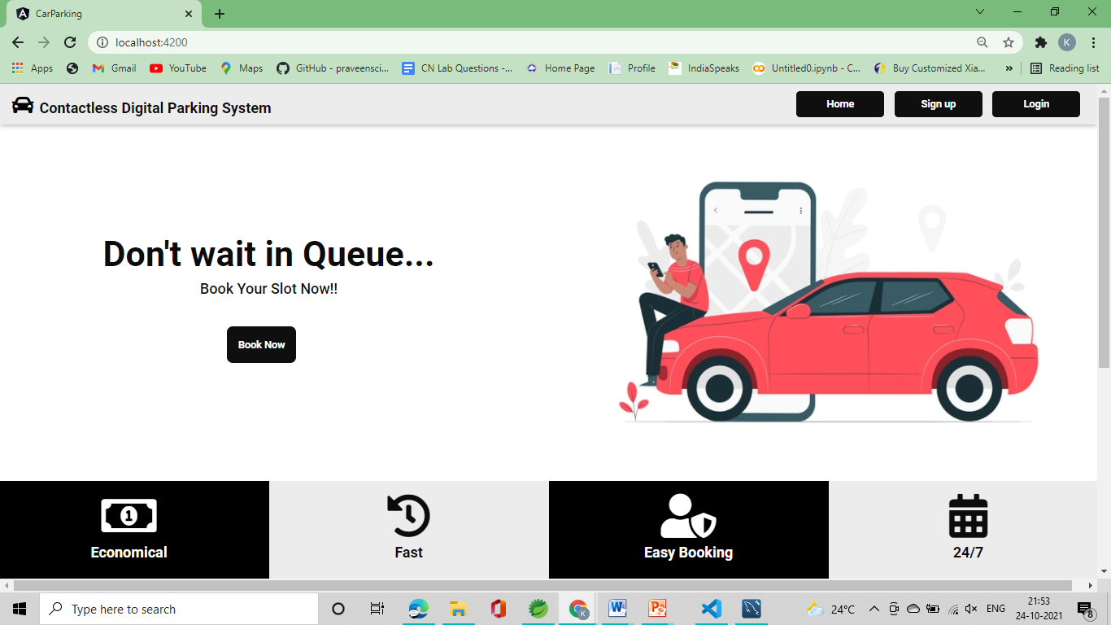
Login page
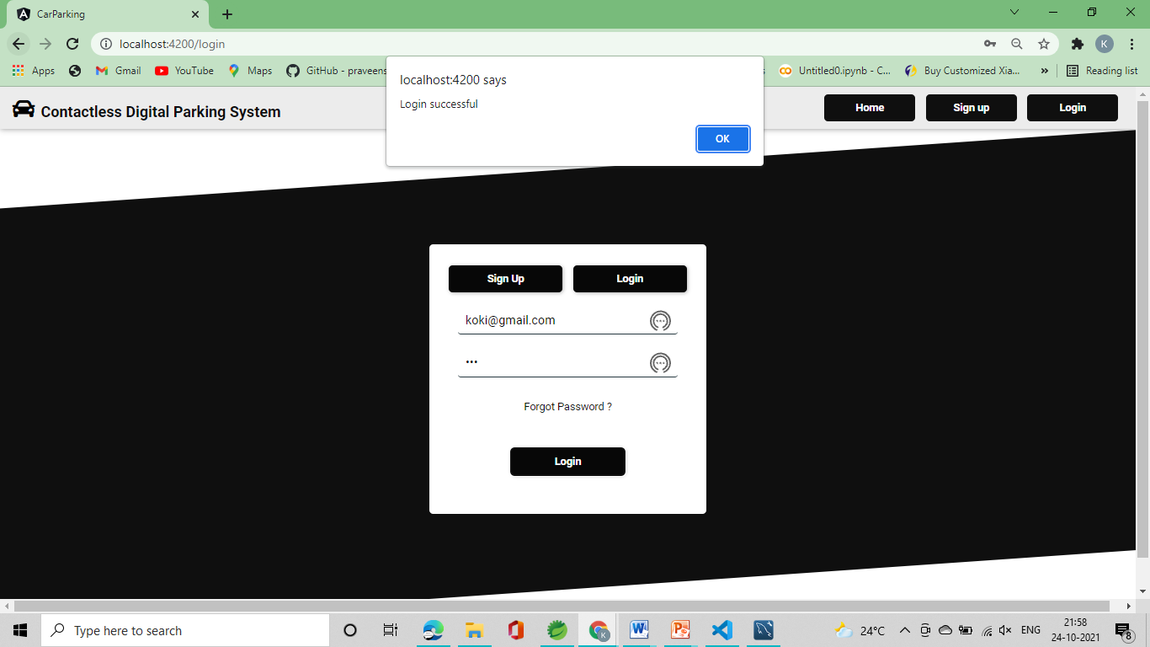
Signup :
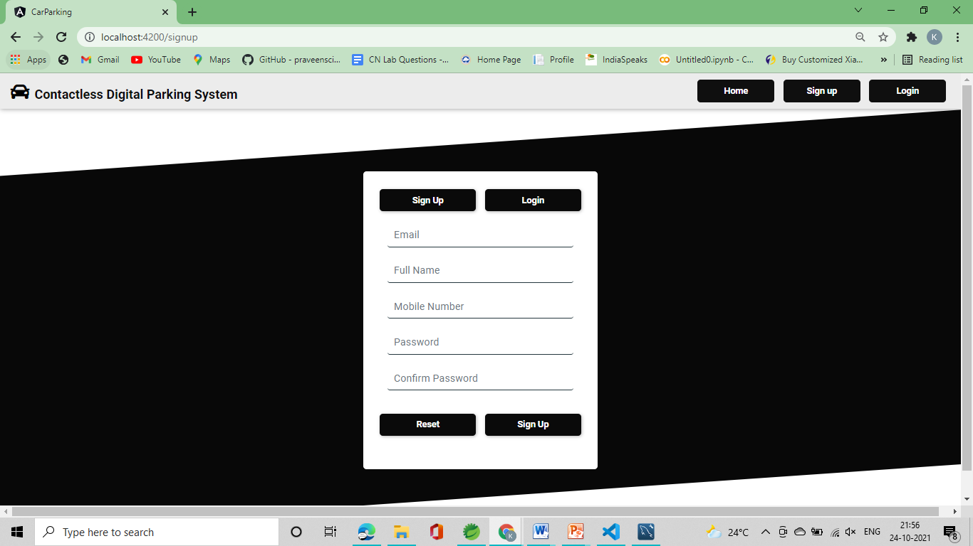
Available slot
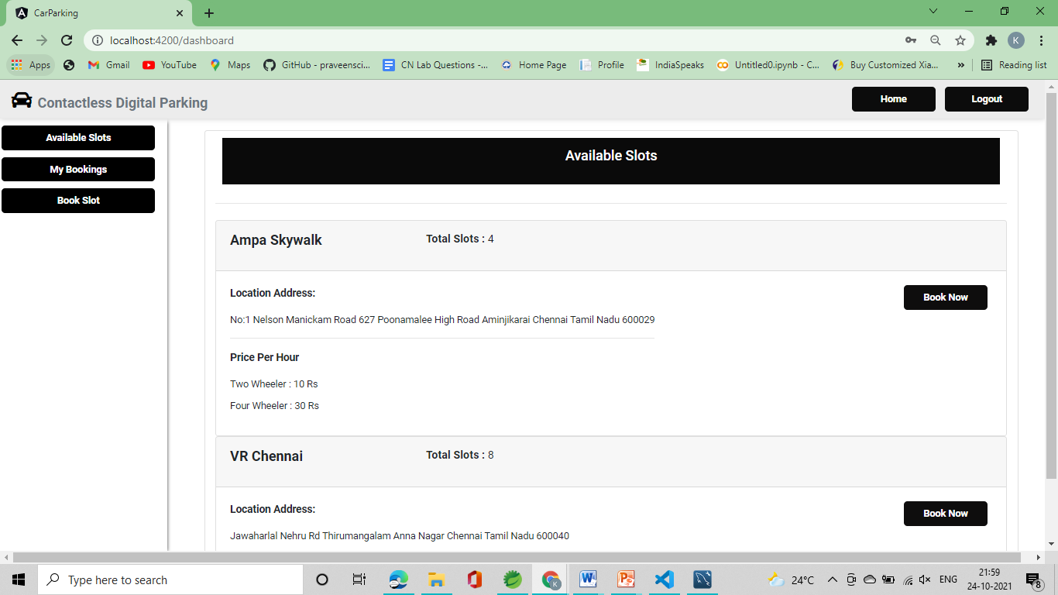

Book slot
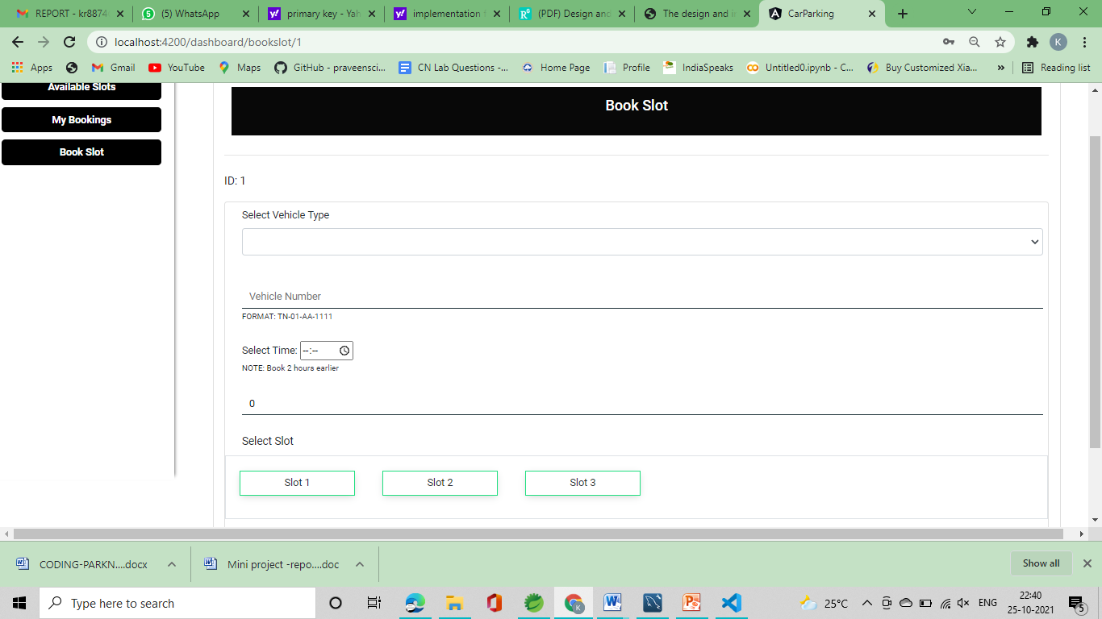

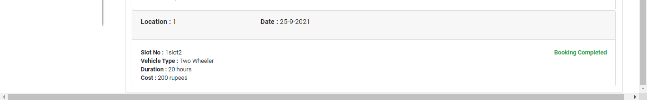

Admin login:
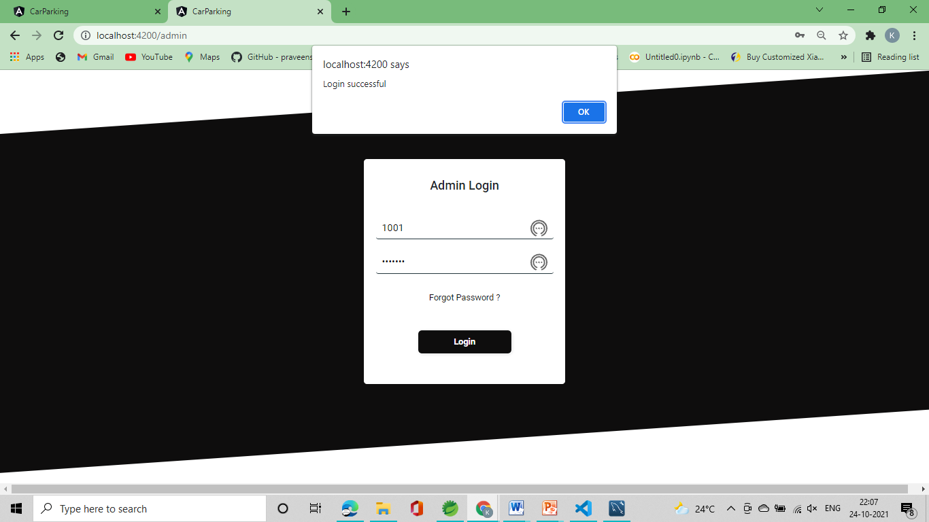

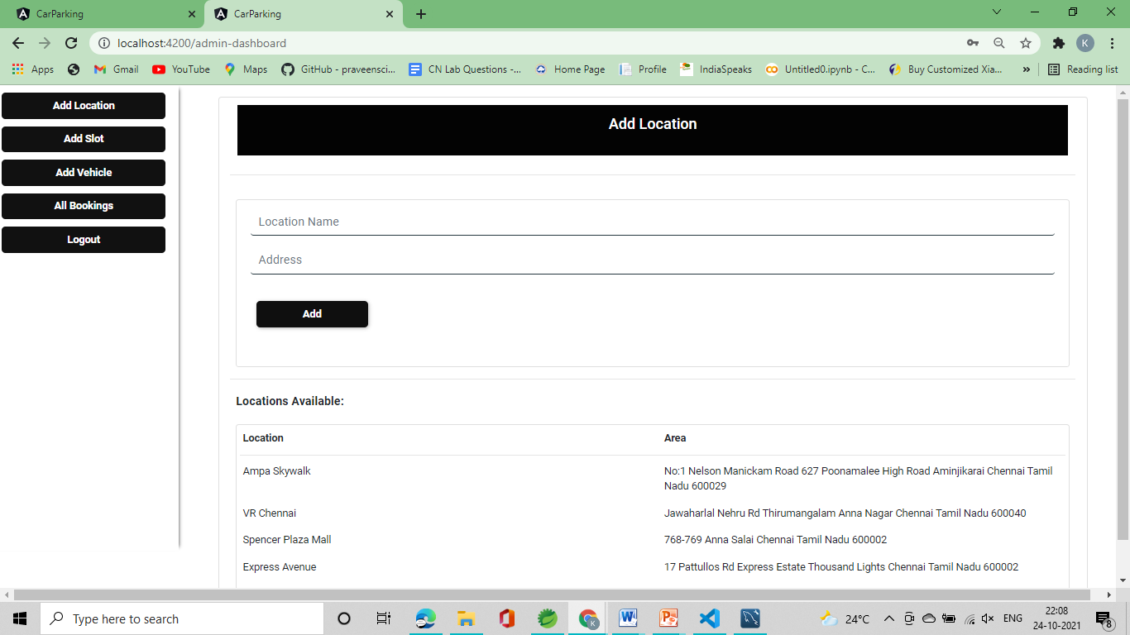
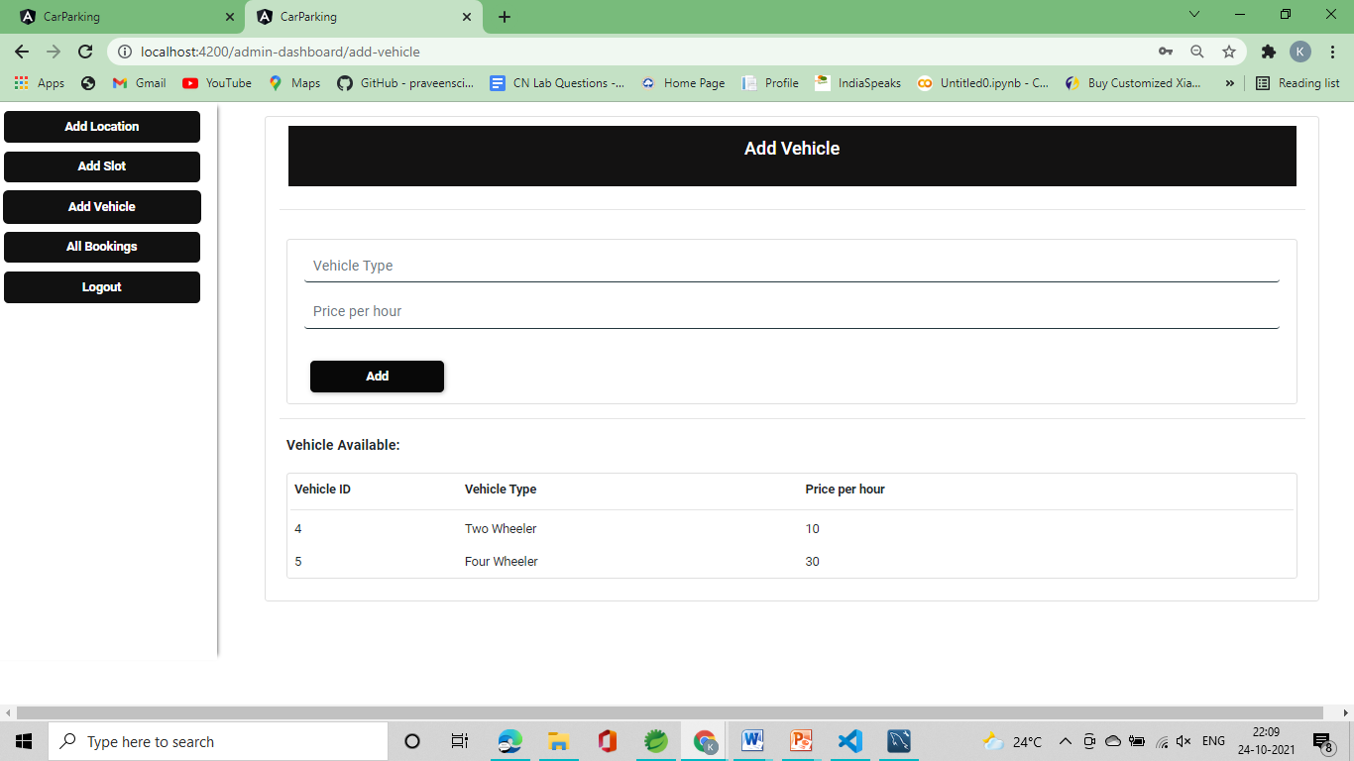
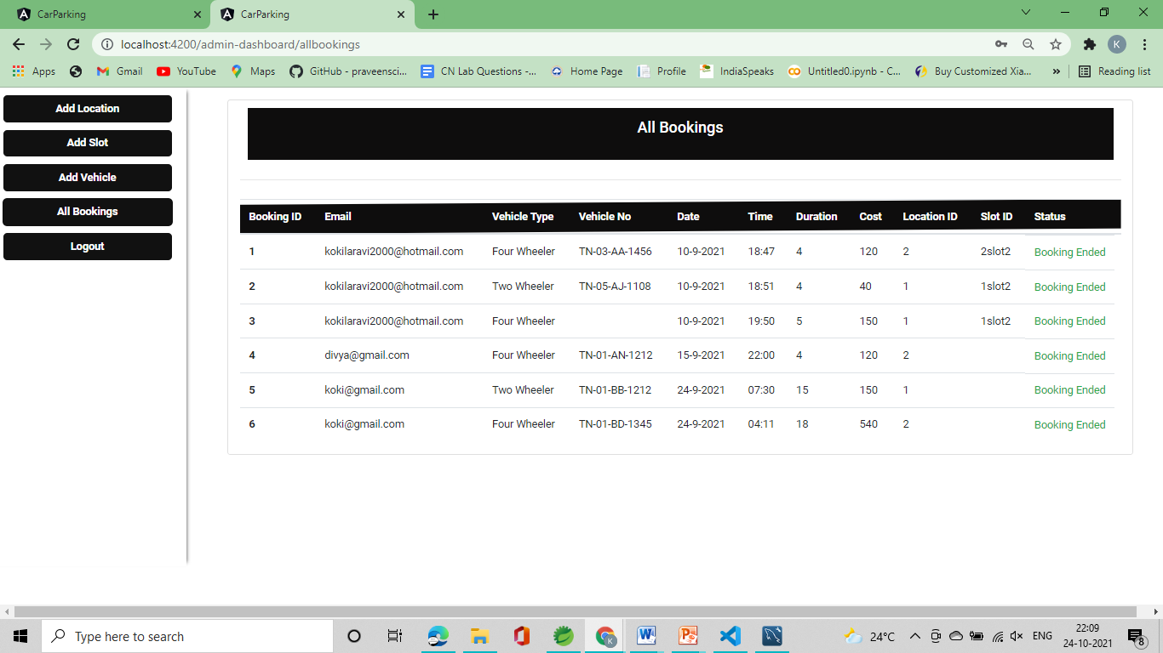

8.2 CODING
Admin:
Admin-dashboard
Add_location:
Css:
.wrapper{
background-color: #0f0f0f;
clip-path: polygon(0 16%, 100% 0, 100% 84%, 0% 100%);
}
.formwrapper{
background-color: white;
border: none;
border-radius: 5px;
}
.button{
margin-left: 7px;
margin-right: 7px;
border: none;
width: 150px;
color: white;
height: 35px;
background-color: #0f0f0f;
font-weight: 900;
border-radius: 5px;
box-shadow: 1px 1px 5px rgba(128, 128, 128, 0.589);
}
.input{
margin-top: 10px;
padding: 5px 10px;
border: none;
border-bottom: 1px solid #1b2f36;
color: black;
transition: all .2s ease-in-out;
}

.input:focus{
border: none;
outline: none;
border-bottom: 1px solid #0a0a0a;
}
Html:
<div class="row mt-3 justify-content-center">
<div class="col-md-11 card" >
<div class="row " style="background-color: #030303;color: white;margin: 10px;padding: 10px;">
<div class="col-md-12 d-flex justify-content-center" >
<h2>Add Location</h2>
</div>
</div>
<hr>
<div class="row mt-2">
<div class="col-md-12">
<div class="row mb-3">
<div class="col-md-12">
<form name="form" [formGroup] = "form" (ngSubmit) = "form.valid && onSubmit()" class="card m-2">
<div class="col-md-12">
<div class="m-1">
<input class="input form-control" formControlName="location_name" [ngClass]="{ 'is-invalid':form.get('location_name').touched && form.get('location_name').invalid}" name="location_name" type="text" placeholder="Location Name" autocomplete="off" required>
<div class="invalid-feedback">
<div>
This Field is required!!
</div>
</div>
</div>
</div>
<div class="col-md-12 ">
<div class="m-1">
<input class="input form-control" formControlName="area" [ngClass]="{ 'is-invalid':form.get('area').touched && form.get('area').invalid}" name="area" type="text" placeholder="Address" required>
<div class="invalid-feedback">
<div>
This Field is required!!
</div>
</div>
</div>
</div>
<div class="col-md-12 mt-2 mb-5 ">
<div class="m-1 mt-4">
<button class="button" type="submit" [disabled]="!form.valid">Add</button>
</div>
</div>
</form>
<hr>
<div class="m-2">
<h3 class="font-weight-bold">Locations Available:</h3>
</div>

<div class="card m-2">
<div class="row p-2">
<div class="col">
<b>Location</b>
</div>
<div class="col">
<b>Area</b>
</div>
</div>
<hr class="m-1">
<div class="row p-2" *ngFor='let location of locations$'>
<div class="col" >
{{location.location_name}}
</div>
<div class="col">
{{location.area}}
</div>
</div>
</div>
</div>
</div>
</div>
</div>
</div>
</div>
Components_spects
import { async, ComponentFixture, TestBed } from '@angular/core/testing';

import { AddLocationComponent } from './add-location.component';

describe('AddLocationComponent', () => {
let component: AddLocationComponent;
let fixture: ComponentFixture<AddLocationComponent>;

beforeEach(async(() => {
TestBed.configureTestingModule({
declarations: [ AddLocationComponent ]
})
.compileComponents();
}));

beforeEach(() => {
fixture = TestBed.createComponent(AddLocationComponent);
component = fixture.componentInstance;
fixture.detectChanges();
});

it('should create', () => {
expect(component).toBeTruthy();
});
});

Compotents_ts
import { Component, OnInit } from '@angular/core';
import { FormGroup, FormControl, Validators } from '@angular/forms';
import { LocationsService } from 'src/app/services/locations.service';
import { Locations } from 'src/app/models/locations.model';

@Component({
selector: 'app-add-location',
templateUrl: './add-location.component.html',
styleUrls: ['./add-location.component.css']
})
export class AddLocationComponent implements OnInit {

form = new FormGroup({
location_name : new FormControl('', Validators.required),
area : new FormControl('', Validators.required)
})

constructor(private locationService: LocationsService) { }

locations$ : Locations[];

ngOnInit(): void {
this.loadLocations();
}

onSubmit(){
this.locationService.addLocation(JSON.stringify(this.form.value))
.subscribe((data => {
if(data == true){
alert("Location Added")
}
else{
alert('Something went wrong')
}
}))
}

loadLocations(){
return this.locationService.getLocations()
.subscribe(data => this.locations$ = data)
}
}

Add_slot:
Css:
.wrapper{
background-color: #080808;
clip-path: polygon(0 16%, 100% 0, 100% 84%, 0% 100%);
}

.formwrapper{
background-color: white;
border: none;
border-radius: 5px;
}

.button{
margin-left: 7px;
margin-right: 7px;
border: none;
width: 150px;
color: white;
height: 35px;
background-color: #0e0d0d;
font-weight: 900;
border-radius: 5px;
box-shadow: 1px 1px 5px rgba(128, 128, 128, 0.589);
}

.input{
margin-top: 10px;
padding: 5px 10px;
border: none;
border-bottom: 1px solid #1b2f36;
color: black;
transition: all .2s ease-in-out;
}

.input:focus{
border: none;
outline: none;
border-bottom: 1px solid #080808;
}

.slots{
overflow-x: hidden;
height: 15rem;
}
Html:
<div class="row mt-3 justify-content-center">
<div class="col-md-11 card" >
<div class="row " style="background-color: #0a0a0a;color: white;margin: 10px;padding: 10px;">
<div class="col-md-12 d-flex justify-content-center" >
<h2>Add Slot</h2>
</div>
</div>
<hr>
<div class="row mt-2">
<div class="col-md-12">
<div class="row mb-3">
<div class="col-md-12">
<form name="form" [formGroup] = "form" (ngSubmit) = "form.valid && onSubmit()" class="card m-2">

<div class="col-md-12">
<div class="m-1">
<div class="form-group">
<label ><h3 class="font-weight-bold m-0">Select Location:</h3></label>
<select class="form-control" formControlName="locationid" [ngClass]="{ 'is-invalid':form.get('locationid').touched && form.get('locationid').invalid}" name="locationid">
<option *ngFor='let location of locations$' value="{{location.locationid}}">{{location.locationid}}. {{location.location_name}}</option>
</select>
<div class="invalid-feedback">
<div>
This Field is required!!
</div>
</div>
</div>
</div>
</div>

<div class="col-md-12">
<div class="m-1">
<input class="input form-control" formControlName="slotid" [ngClass]="{ 'is-invalid':form.get('slotid').touched && form.get('slotid').invalid}" name="slotid" type="text" placeholder="Slot ID" autocomplete="off" required>
<small>Format: slotid + slot + slotno</small>
<div class="invalid-feedback">
<div>
This Field is required!!
</div>
</div>
</div>
</div>
<div class="col-md-12 ">
<div class="m-1">
<input class="input form-control" formControlName="slotno" [ngClass]="{ 'is-invalid':form.get('slotno').touched && form.get('slotno').invalid}" name="slotno" type="text" placeholder="Slot Number" required>
<small>Format: Slot + slotno</small>
<div class="invalid-feedback">
<div>
This Field is required!!
</div>
</div>
</div>
</div>
<div class="col-md-12 mt-2 mb-2 ">
<div class="m-1 mt-4">
<button class="button" type="submit" [disabled]="!form.valid">Add</button>
</div>
</div>
</form>
<hr>
<div class="m-2">
<h3 class="font-weight-bold">Slots Available:</h3>
</div>
<div class="card m-2 slots">
<div class="row p-2">
<div class="col-2">
<b>Location ID</b>
</div>
<div class="col-4">
<b>Slot ID</b>
</div>
<div class="col-4">
<b>Slot Number</b>
</div>
</div>
<hr class="m-1">
<div class="row p-2" *ngFor='let slot of slots$'>
<div class="col-2" >
{{slot.locationid}}
</div>
<div class="col-4">
{{slot.slotid}}
</div>
<div class="col-4">
{{slot.slotno}}
</div>
</div>
</div>
</div>
</div>
</div>
</div>
</div>
</div>
Components.spects:
import { async, ComponentFixture, TestBed } from '@angular/core/testing';

import { AddSlotComponent } from './add-slot.component';

describe('AddSlotComponent', () => {
let component: AddSlotComponent;
let fixture: ComponentFixture<AddSlotComponent>;

beforeEach(async(() => {
TestBed.configureTestingModule({
declarations: [ AddSlotComponent ]
})
.compileComponents();
}));

beforeEach(() => {
fixture = TestBed.createComponent(AddSlotComponent);
component = fixture.componentInstance;
fixture.detectChanges();
});

it('should create', () => {
expect(component).toBeTruthy();
});
});

Compotents_ts
import { Component, OnInit } from '@angular/core';
import { FormGroup, FormControl, Validators } from '@angular/forms';
import { SlotsService } from 'src/app/services/slots.service';
import { Slots } from 'src/app/models/slots.model';
import { LocationsService } from 'src/app/services/locations.service';
import { Locations } from 'src/app/models/locations.model';

@Component({
selector: 'app-add-slot',
templateUrl: './add-slot.component.html',
styleUrls: ['./add-slot.component.css']
})
export class AddSlotComponent implements OnInit {

slots$: Slots[];
locations$: Locations[];
form = new FormGroup({
locationid : new FormControl('', Validators.required),
slotid : new FormControl('', Validators.required),
slotno : new FormControl('', Validators.required)
})
constructor(private slotService: SlotsService, private locationService : LocationsService) { }

ngOnInit(): void {
this.getAllSlots();
this.loadLocations();
}
onSubmit(){
this.slotService.addSlot(JSON.stringify(this.form.value))
.subscribe((data => {
if(data == true){
alert("Slot Added")
}
else{
alert('Something went wrong')
}
}))
}

getAllSlots(){
this.slotService.getAllSlots()
.subscribe(data => this.slots$ = data)
}

loadLocations(){
return this.locationService.getLocations()
.subscribe(data => this.locations$ = data)
}
}

Add_vehicle:
Css:
.wrapper{
background-color: #0c0c0c;
clip-path: polygon(0 16%, 100% 0, 100% 84%, 0% 100%);
}

.formwrapper{
background-color: white;
border: none;
border-radius: 5px;
}

.button{
margin-left: 7px;
margin-right: 7px;
border: none;
width: 150px;
color: white;
height: 35px;
background-color: #080808;
font-weight: 900;
border-radius: 5px;
box-shadow: 1px 1px 5px rgba(128, 128, 128, 0.589);
}

.input{
margin-top: 10px;
padding: 5px 10px;
border: none;
border-bottom: 1px solid #1b2f36;
color: black;
transition: all .2s ease-in-out;
}
.input:focus{
border: none;
outline: none;
border-bottom: 1px solid #0e0d0d;
}
Html:
<div class="row mt-3 justify-content-center">
<div class="col-md-11 card" >
<div class="row " style="background-color: #131212;color: white;margin: 10px;padding: 10px;">
<div class="col-md-12 d-flex justify-content-center" >
<h2>Add Vehicle</h2>
</div>
</div>
<hr>
<div class="row mt-2">
<div class="col-md-12">
<div class="row mb-3">
<div class="col-md-12">
<form name="form" [formGroup] = "form" (ngSubmit) = "form.valid && onSubmit()" class="card m-2">

<div class="col-md-12">
<div class="m-1">
<input class="input form-control" formControlName="vehicle_type" [ngClass]="{ 'is-invalid':form.get('vehicle_type').touched && form.get('vehicle_type').invalid}" name="vehicle_type" type="text" placeholder="Vehicle Type" autocomplete="off" required>
<div class="invalid-feedback">
<div>
This Field is required!!
</div>
</div>
</div>
</div>
<div class="col-md-12 ">
<div class="m-1">
<input class="input form-control" formControlName="cost" [ngClass]="{ 'is-invalid':form.get('cost').touched && form.get('cost').invalid}" name="cost" type="text" placeholder="Price per hour" autocomplete="off" required>
<div class="invalid-feedback">
<div>
This Field is required!!
</div>
</div>
</div>
</div>
<div class="col-md-12 mt-2 mb-2 ">
<div class="m-1 mt-4">
<button class="button" type="submit" [disabled]="!form.valid">Add</button>
</div>
</div>
</form>
<hr>
<div class="m-2">
<h3 class="font-weight-bold">Vehicle Available:</h3>
</div>
<div class="card m-2 slots">
<div class="row p-2">
<div class="col-2">
<b>Vehicle ID</b>
</div>
<div class="col-4">
<b>Vehicle Type</b>
</div>
<div class="col-4">
<b>Price per hour</b>
</div>
</div>
<hr class="m-1">
<div class="row p-2" *ngFor='let vehicle of vehicles$'>
<div class="col-2" >
{{vehicle.vehicleid}}
</div>
<div class="col-4">
{{vehicle.vehicle_type}}
</div>
<div class="col-4">
{{vehicle.cost}}
</div>
</div>
</div>
</div>
</div>
</div>
</div>
</div>
</div>
Compotents.spec.ts
import { async, ComponentFixture, TestBed } from '@angular/core/testing';

import { AddVehicleComponent } from './add-vehicle.component';

describe('AddVehicleComponent', () => {
let component: AddVehicleComponent;
let fixture: ComponentFixture<AddVehicleComponent>;

beforeEach(async(() => {
TestBed.configureTestingModule({
declarations: [ AddVehicleComponent ]
})
.compileComponents();
}));

beforeEach(() => {
fixture = TestBed.createComponent(AddVehicleComponent);
component = fixture.componentInstance;
fixture.detectChanges();
});

it('should create', () => {
expect(component).toBeTruthy();
});
});
Compotents.ts
import { Component, OnInit } from '@angular/core';
import { Vehicle } from 'src/app/models/vehicle.model';
import { FormGroup, FormControl, Validators } from '@angular/forms';
import { VehicleService } from 'src/app/services/vehicle.service';

@Component({
selector: 'app-add-vehicle',
templateUrl: './add-vehicle.component.html',
styleUrls: ['./add-vehicle.component.css']
})
export class AddVehicleComponent implements OnInit {
vehicles$ : Vehicle[];
form = new FormGroup({
vehicle_type : new FormControl('', Validators.required),
cost : new FormControl('', Validators.required)
})
constructor(private vehicleservice : VehicleService) { }
ngOnInit(): void {
this.loadVehicle();
}
loadVehicle(){
this.vehicleservice.getVehicles()
.subscribe(data => this.vehicles$ = data)
}
onSubmit(){
this.vehicleservice.addVehicle(JSON.stringify(this.form.value))
.subscribe(data => console.log(data))
alert('Vehicle Added')
location.reload();
}
}
Allbooking
Css
.thead{
background-color: #0e0d0d;
clip-path: polygon(0 16%, 100% 0, 100% 84%, 0% 100%);
color: white;
}
Html
<div class="row mt-3 justify-content-center">
<div class="col-md-11 card" >
<div class="row " style="background-color: #0e0d0d;color: white;margin: 10px;padding: 10px;">
<div class="col-md-12 d-flex justify-content-center" >
<h2>All Bookings</h2>
</div>
</div>
<hr>
<div class="row mt-2">
<div class="col-md-12">
<table class="table">
<thead class="thead">
<tr>
<th scope="col">Booking ID</th>
<th scope="col">Email</th>
<th scope="col">Vehicle Type</th>
<th scope="col">Vehicle No</th>
<th scope="col">Date</th>
<th scope="col">Time</th>
<th scope="col">Duration</th>
<th scope="col">Cost</th>
<th scope="col">Location ID</th>
<th scope="col">Slot ID</th>
<th scope="col">Status</th>
</tr>
</thead>
<tbody >
<tr *ngFor='let booking of AllBookings$'>
<th scope="row">{{booking.bookingid}}</th>
<td>{{booking.email}}</td>
<td>{{booking.vehicle_type}}</td>
<td>{{booking.vehicle_no}}</td>
<td>{{booking.date}}</td>
<td>{{booking.time}}</td>
<td>{{booking.duration}}</td>
<td>{{booking.cost}}</td>
<td>{{booking.locationid}}</td>
<td>{{booking.slotid}}</td>
<div *ngIf='booking.paid == 1'>
<td class="text-success">Booking Ended</td>
</div>
<div *ngIf='booking.paid == 0'>
<td class="text-danger">Booking ongoing</td>
</div>
</tr>
</tbody>
</table>
</div>
</div>
</div>
</div>
Compotets.spec.ts
import { async, ComponentFixture, TestBed } from '@angular/core/testing';
import { AllbookingsComponent } from './allbookings.component';
describe('AllbookingsComponent', () => {
let component: AllbookingsComponent;
let fixture: ComponentFixture<AllbookingsComponent>;
beforeEach(async(() => {
TestBed.configureTestingModule({
declarations: [ AllbookingsComponent ]
})
.compileComponents();
}));
beforeEach(() => {
fixture = TestBed.createComponent(AllbookingsComponent);
component = fixture.componentInstance;
fixture.detectChanges();
});
it('should create', () => {
expect(component).toBeTruthy();
});
});

#admin-dashboard.components.css
.sidebar{
box-shadow: 5px 0 5px -5px #333 ;
height: 90vh;
}
.button{
border: none;
width: 220px;
margin-top: 10px;
color: white;
height: 35px;
background-color: #111111;
font-weight: 900;
border-radius: 5px;
}
Admin-dashboard-html
<!-- <app-header-login></app-header-login> -->
<div class="row justify-content-center">
<div class="col-md-2 p-0 sidebar d-flex align-items-center flex-column">
<div>
<button routerLink="/admin-dashboard" class="button">Add Location</button>
</div>
<div>
<button routerLink="/admin-dashboard/add-slot" class="button">Add Slot</button>
</div>
<div>
<button routerLink="/admin-dashboard/add-vehicle" class="button">Add Vehicle</button>
</div>
<div>
<button routerLink="/admin-dashboard/allbookings" class="button">All Bookings</button>
</div>
<div>
<button (click)="logout()" class="button">Logout</button>
</div>
</div>
<div class="col-md-10">
<router-outlet></router-outlet>
</div>
</div>
Admin-dashboadrd-spec.ts
import { async, ComponentFixture, TestBed } from '@angular/core/testing';
import { AdminDashboardComponent } from './admin-dashboard.component';
describe('AdminDashboardComponent', () => {
let component: AdminDashboardComponent;
let fixture: ComponentFixture<AdminDashboardComponent>;
beforeEach(async(() => {
TestBed.configureTestingModule({
declarations: [ AdminDashboardComponent ]
})
.compileComponents();
}));
beforeEach(() => {
fixture = TestBed.createComponent(AdminDashboardComponent);
component = fixture.componentInstance;
fixture.detectChanges();
});
it('should create', () => {
expect(component).toBeTruthy();
});
});
admin-dashborad-ts
import { Component, OnInit } from '@angular/core';
import { Router } from '@angular/router';
@Component({
selector: 'app-admin-dashboard',
templateUrl: './admin-dashboard.component.html',
styleUrls: ['./admin-dashboard.component.css']
})
export class AdminDashboardComponent implements OnInit {
constructor(private route: Router) { }
ngOnInit(): void {
this.checkLogin();
}
logout(){
sessionStorage.clear()
this.route.navigate(['admin'])
}
checkLogin(){
if (sessionStorage.length == 0){
this.route.navigate(['admin'])
}
}
}
Admin-login
Css
.wrapper{
background-color: #0e0d0d;
clip-path: polygon(0 16%, 100% 0, 100% 84%, 0% 100%);
}
.formwrapper{
background-color: white;
border: none;
border-radius: 5px;
}
.button{
margin-left: 7px;
margin-right: 7px;
border: none;
width: 150px;
color: white;
height: 35px;
background-color: #0e0d0d;
font-weight: 900;
border-radius: 5px;
box-shadow: 1px 1px 5px rgba(128, 128, 128, 0.589);
}
.input{
margin-top: 10px;
padding: 5px 10px;
border: none;
width: 290px;
border-bottom: 1px solid #1b2f36;
color: black;
transition: all .2s ease-in-out;
}
.input:focus{
border: none;
outline: none;
border-bottom: 1px solid #0c0c0c;
}
HTML
<div class="row">
<div class="col-md-12 wrapper d-flex justify-content-center align-items-center" style="height:95vh">
<div class="row d-flex justify-content-center align-items-center formwrapper card">
<form name="form" [formGroup] = "form" (ngSubmit) = "form.valid && onSubmit()">
<div class="col-md-12 mt-4 d-flex flex-row justify-content-center">
<div class="m-1">
<!-- <button class="button" routerLink="/signup">Sign Up </button>
<button class="button" routerLink="/login">Login</button> -->
<h2>Admin Login</h2>
</div>
</div>
<div class="col-md-12 d-flex flex-row justify-content-center">
<div class="m-1">
<input class="input form-control" formControlName="adminid" [ngClass]="{ 'is-invalid':form.get('adminid').touched && form.get('adminid').invalid}" name="adminid" type="email" placeholder="Admin ID" autocomplete="off" required>
<div class="invalid-feedback">
<div *ngIf="form.get('adminid').errors?.required">
This Field is required!!
</div>
</div>
</div>
</div>
<div class="col-md-12 d-flex flex-row justify-content-center">
<div class="m-1">
<input class="input form-control" formControlName="password" [ngClass]="{ 'is-invalid':form.get('password').touched && form.get('password').invalid }" type="password" placeholder="Password" required>
<div class="invalid-feedback">
<div>
This Field is required!!
</div>
</div>
</div>
</div>
<div class="col-md-12 d-flex flex-row justify-content-center">
<div class="mt-4">
<p class="danger"><button style="border:none;background-color: transparent;color: #0e0d0d;">Forgot Password ?</button></p>
</div>
</div>
<div class="col-md-12 mt-2 mb-5 d-flex flex-row justify-content-center">
<div class="m-1 mt-4">
<button class="button" type="submit" [disabled]="!form.valid" >Login</button>
</div>
</div>
</form>
</div>
</div>
</div>
SPECTS
import { async, ComponentFixture, TestBed } from '@angular/core/testing';
import { AdminLoginComponent } from './admin-login.component';
describe('AdminLoginComponent', () => {
let component: AdminLoginComponent;
let fixture: ComponentFixture<AdminLoginComponent>;
beforeEach(async(() => {
TestBed.configureTestingModule({
declarations: [ AdminLoginComponent ]
})
.compileComponents();
}));
beforeEach(() => {
fixture = TestBed.createComponent(AdminLoginComponent);
component = fixture.componentInstance;
fixture.detectChanges();
});
it('should create', () => {
expect(component).toBeTruthy();
});
});
TS
import { async, ComponentFixture, TestBed } from '@angular/core/testing';
import { LoginComponent } from './login.component';
describe('LoginComponent', () => {
let component: LoginComponent;
let fixture: ComponentFixture<LoginComponent>;

beforeEach(async(() => {
TestBed.configureTestingModule({
declarations: [ LoginComponent ]
})
.compileComponents();
}));
beforeEach(() => {
fixture = TestBed.createComponent(LoginComponent);
component = fixture.componentInstance;
fixture.detectChanges();
});
it('should create', () => {
expect(component).toBeTruthy();
});
});
TS
import { Component, OnInit } from '@angular/core';
import { FormGroup, FormControl, Validators } from '@angular/forms';
import { UsersService } from 'src/app/services/users.service';
import { Router } from '@angular/router';
@Component({
selector: 'app-login',
templateUrl: './login.component.html',
styleUrls: ['./login.component.css']
})
export class LoginComponent implements OnInit {

form = new FormGroup({
email : new FormControl('', [Validators.required, Validators.email]),
password : new FormControl('', Validators.required)
})
constructor(private usersService: UsersService, public router: Router) { }

ngOnInit(): void {
this.checkLogin();
}
onSubmit() {
var loginJson = JSON.stringify(this.form.value);
this.usersService.loginCheck(loginJson)
.subscribe((data => {
if(data == true){
alert("Login successful");
var jsonData = JSON.parse(loginJson);
this.storeLogin(jsonData['email']);
this.router.navigate(['/dashboard']);
}
else{
alert("Invalid Login");
}
}))
}

storeLogin(email){
sessionStorage.setItem("email", email);
}
checkLogin(){
if (sessionStorage.length != 0){
this.router.navigate(['/']);
}
}
}
SIGNUP
CSS
.wrapper{
background-color: #080808;
clip-path: polygon(0 16%, 100% 0, 100% 84%, 0% 100%);
}
.formwrapper{
background-color: white;
border: none;
border-radius: 5px;
}
.button{
margin-left: 7px;
margin-right: 7px;
border: none;
width: 150px;
color: white;
height: 35px;
background-color: #0a0a0a;
font-weight: 900;
border-radius: 5px;
box-shadow: 1px 1px 5px rgba(128, 128, 128, 0.589);
}
.input{
margin-top: 10px;
padding: 5px 10px;
border: none;
width: 290px;
border-bottom: 1px solid #1b2f36;
color: black;
transition: all .2s ease-in-out;
}
.input:focus{
border: none;
outline: none;
border-bottom: 1px solid #080808;
}
HTML
<app-header></app-header>
<div class="row">
<div class="col-md-12 wrapper d-flex justify-content-center align-items-center" style="height:95vh">
<div class="row d-flex justify-content-center align-items-center formwrapper card">
<form name="form" [formGroup] = "form" (ngSubmit) = "form.valid && onSubmit()">
<div class="col-md-12 mt-4 d-flex flex-row justify-content-center">
<div class="m-1">
<button class="button" routerLink="/signup">Sign Up </button>
<button class="button" routerLink="/login">Login</button>
</div>
</div>
<div class="col-md-12 d-flex flex-row justify-content-center">
<div class="m-1">
<input class="input form-control" formControlName="email" [ngClass]="{ 'is-invalid':form.get('email').touched && form.get('email').invalid}" autocomplete="off" type="email" placeholder="Email">
<div class="invalid-feedback">
<div *ngIf="form.get('email').errors?.required">
This Field is required!!
</div>
<div *ngIf="form.get('email').errors?.email">
Enter Valid Email Address!!
</div>
</div>
</div>
</div>
<div class="col-md-12 d-flex flex-row justify-content-center">
<div class="m-1">
<input class="input form-control" formControlName="fullname" [ngClass]="{ 'is-invalid':form.get('fullname').touched && form.get('fullname').invalid}" type="text" placeholder="Full Name">
<button class="button" [disabled]="!form.valid">Sign Up</button>
</div>
</div>
</form>
</div>
</div>
</div>
SPECT
import { async, ComponentFixture, TestBed } from '@angular/core/testing';
import { SignupComponent } from './signup.component';
describe('SignupComponent', () => {
let component: SignupComponent;
let fixture: ComponentFixture<SignupComponent>;
beforeEach(async(() => {
TestBed.configureTestingModule({
declarations: [ SignupComponent ]
})
.compileComponents();
}));

beforeEach(() => {
fixture = TestBed.createComponent(SignupComponent);
component = fixture.componentInstance;
fixture.detectChanges();
});

it('should create', () => {
expect(component).toBeTruthy();
});
});

TS
import { async, ComponentFixture, TestBed } from '@angular/core/testing';
import { SignupComponent } from './signup.component';

describe('SignupComponent', () => {
let component: SignupComponent;
let fixture: ComponentFixture<SignupComponent>;

beforeEach(async(() => {
TestBed.configureTestingModule({
declarations: [ SignupComponent ]
})
.compileComponents();
}));

beforeEach(() => {
fixture = TestBed.createComponent(SignupComponent);
component = fixture.componentInstance;
fixture.detectChanges();
});

it('should create', () => {
expect(component).toBeTruthy();
});
});

DASHBOARD:
BOOKING
CSS
.button{
margin-left: 7px;
margin-right: 7px;
border: none;
width: 120px;
color: white;
height: 35px;
background-color: #080808;
font-weight: 900;
border-radius: 5px;
}
::-webkit-scrollbar {
width: 0px;
background: transparent; /* make scrollbar transparent */
}
HTML
<div class="row mt-3 justify-content-center">
<div class="col-md-11 card " >
<div class="row " style="background-color: #070707;color: white;margin: 10px;padding: 10px;">
<div class="col-md-12 d-flex justify-content-center" >
<h2>My Bookings</h2>
</div>
</div>
<hr>
<div class="row mt-2">
<div class="col-md-12">
<div class="row mb-3">
<div class="col-md-12 overflow-auto" style="height: 35rem;">
<div class="accordion" id="accordionExample">
<div *ngIf='!show'>
<div *ngFor='let booking of bookings$' class="card">
<div class="card-header" id="headingTwo">
<div class="row">
<div class="col-md-3">
<h3><b>Location :</b> {{booking.locationid}}</h3>
</div>
<div class="col-md-7">
<h3><b>Date :</b> {{booking.date}}</h3>
</div>
SPECTS
import { async, ComponentFixture, TestBed } from '@angular/core/testing';

import { BookingsComponent } from './bookings.component';

describe('BookingsComponent', () => {
let component: BookingsComponent;
let fixture: ComponentFixture<BookingsComponent>;

beforeEach(async(() => {
TestBed.configureTestingModule({
declarations: [ BookingsComponent ]
})
.compileComponents();
}));

beforeEach(() => {
fixture = TestBed.createComponent(BookingsComponent);
component = fixture.componentInstance;
fixture.detectChanges();
});

it('should create', () => {
expect(component).toBeTruthy();
});
});

TS
import { Component, OnInit } from '@angular/core';
import { Bookings } from 'src/app/models/bookings.model';
import { BookingsService } from 'src/app/services/bookings.service';
import { Router } from '@angular/router';

@Component({
selector: 'app-bookings',
templateUrl: './bookings.component.html',
styleUrls: ['./bookings.component.css']
})
export class BookingsComponent implements OnInit {

show: boolean;
email$ = sessionStorage.getItem('email');
bookings$: Bookings[] = [];

constructor(private bookingsService: BookingsService,
public router: Router) { }

ngOnInit() {
this.checkLogin();
this.getBookingById();

}

getBookingById(){
return this.bookingsService.getBookings(this.email$)
.subscribe(data => {this.bookings$ = data, this.checkBookingFn();})
}

endBooking(bookingid){
return this.bookingsService.endBooking(bookingid)
.subscribe((data:{}) => {
alert('Booking Ended');
location.reload();
this.router.navigate(['dashboard/bookings'])
})
}
checkBookingFn(){
console.log()
if (this.bookings$.length == 0){
this.show = true
}
else{
this.show = false
}
}

checkLogin(){
if (sessionStorage.length == 0){
this.router.navigate(['login']);
}
}
}
BOOKSLOT
CSS
.formwrapper{
background-color: white;
border: none;
border-radius: 5px;
}
.button{
border: none;
width: 220px;
margin-top: 10px;
color: white;
height: 35px;
background-color: #0e0d0d;
font-weight: 900;
border-radius: 5px;
}
.input{
margin-top: 10px;
padding: 5px 10px;
border: none;
width: 100%;
border-bottom: 1px solid #1b2f36;
color: black;
transition: all .2s ease-in-out;
}
.input:focus{
border: none;
outline: none;
border-bottom: 1px solid #0c0c0c;
}
.button-slot{
border: none;
width: 120px;
margin-top: 10px;
color: white;
height: 35px;
background-color: #0c0c0c;
font-weight: 900;
border-radius: 5px;
}
.button-slot:focus{
border: none;
width: 120px;
margin-top: 10px;
color: white;
height: 35px;
background-color: #0d0d0e;
font-weight: 900;
border-radius: 5px;
}
.button-slot:disabled{
border: none;
width: 120px;
margin-top: 10px;
color: #000;
height: 35px;
background-color: #b5aeae;
font-weight: 900;
border-radius: 5px;
}
input[type="radio"] {
display: none;
}
input[type="radio"]:checked + #slot {
background: hsla(150, 75%, 50%, 1);
color: hsla(215, 0%, 100%, 1);
box-shadow: 0px 0px 10px hsla(150, 100%, 50%, 0.75);

}
input[type = "radio"]:disabled + #slot{
color: hsla(150, 5%, 75%, 1);
border-color: hsla(150, 5%, 75%, 1);
box-shadow: none;
cursor: not-allowed;
}
#slot {
padding: 5px;
display: block;
background: white;
border: 2px solid hsla(150, 75%, 50%, 1);
text-align: center;
box-shadow: 0px 3px 10px -2px hsla(150, 5%, 65%, 0.5);
cursor: pointer;
}
@keyframes ldio-letfb25733-1 {
0% { top: 36px; height: 128px }
50% { top: 60px; height: 80px }
100% { top: 60px; height: 80px }
}
@keyframes ldio-letfb25733-2 {
0% { top: 41.99999999999999px; height: 116.00000000000001px }
50% { top: 60px; height: 80px }
100% { top: 60px; height: 80px }
}
@keyframes ldio-letfb25733-3 {
0% { top: 48px; height: 104px }
50% { top: 60px; height: 80px }
100% { top: 60px; height: 80px }
}
.ldio-letfb25733 div { position: absolute; width: 30px }.ldio-letfb25733 div:nth-child(1) {
left: 35px;
background: #e15b64;
animation: ldio-letfb25733-1 1s cubic-bezier(0,0.5,0.5,1) infinite;
animation-delay: -0.2s
}
.ldio-letfb25733 div:nth-child(2) {
left: 85px;
background: #f8b26a;
animation: ldio-letfb25733-2 1s cubic-bezier(0,0.5,0.5,1) infinite;
animation-delay: -0.1s
}
.ldio-letfb25733 div:nth-child(3) {
left: 135px;
background: #abbd81;
animation: ldio-letfb25733-3 1s cubic-bezier(0,0.5,0.5,1) infinite;
animation-delay: undefineds
}
.loadingio-spinner-pulse-f18fi8swilg {
width: 200px;
height: 200px;
display: inline-block;
overflow: hidden;
background: #ffffff;
}
.ldio-letfb25733 {
width: 100%;
height: 100%;
position: relative;
transform: translateZ(0) scale(1);
backface-visibility: hidden;
transform-origin: 0 0; /* see note above */
}
.ldio-letfb25733 div { box-sizing: content-box; }
HTML
<div class="row mt-3 justify-content-center">
<div class="col-md-11 card" >
<div class="row " style="background-color: #080808;color: white;margin: 10px;padding: 10px;">
<div class="col-md-12 d-flex justify-content-center" >
<h2>Book Slot</h2>
</div>
</div>
<div *ngIf="load" class="d-flex justify-content-center">
<div class="loadingio-spinner-pulse-f18fi8swilg"><div class="ldio-letfb25733">
<div></div><div></div><div></div>
</div>
</div>
</div>
<hr>
<div class="row mt-2">
<div class="col-md-12">
<div class="row mb-3">
<div class="col-md-12">
<h4>ID: {{locationid}}</h4>
<form class="card" name="bookingForm">
<!-- select vehicle -->
<div class="col-md-12 m-2">
<div class="form-group">
<label for="vehicle_type">Select Vehicle Type</label>
<select class="form-control" [(ngModel)]="bookingdetails.vehicle_type" name="vehicle_type" id="vehicle_type">
<option *ngFor='let vehicle of vehicles$' value="{{vehicle.vehicle_type}}">{{vehicle.vehicle_type}}</option>
</select>
</div>
</div>
<!-- end vechicle select -->
<!-- vehicle number enter -->
<div class="col-md-12 m-2">
<input class="input" type="text" [(ngModel)]="bookingdetails.vehicle_no" name="vehicle_no" placeholder="Vehicle Number" autocomplete="off" required>
<small>FORMAT: TN-01-AA-1111</small>
</div>
<!-- end vehicle number -->
<!-- select date and time -->
<div class="col-md-12 mt-2 mb-3">
<div class="row m-2">
<div>
Select Time: <input type="time" id="time" [(ngModel)]="bookingdetails.time" name="time">
<br>
<small>NOTE: Book 2 hours earlier</small>
</div>
</div>
</div>
<!-- end date and time -->
<!-- enter hours -->
<div class="col-md-12 mb-3 ml-2">
<input class="input mt-0" name="duration" id="duration" type="number" min="1" max="24" [(ngModel)]="bookingdetails.duration" id="duration" placeholder="Estimated Hours" autocomplete="off" required>
</div>
<!-- end hours -->
<!-- select slot -->
<div class="col-md-12">
<h4 class="m-2">Select Slot</h4>
<div class="row border ">
<div class="col-2 m-1 pt-3 pb-0" *ngFor="let slot of slots$" >
<div *ngIf="slot.status != 0;" >
<input type="radio" disabled [(ngModel)]="bookingdetails.slotid" id="{{slot.slotno}}" name="slotid" value="{{slot.slotid }}">
<label id="slot" for="{{slot.slotno}}">{{slot.slotno}}</label>
describe('BookslotComponent', () => {
let component: BookslotComponent;
let fixture: ComponentFixture<BookslotComponent>;
beforeEach(async(() => {
TestBed.configureTestingModule({
declarations: [ BookslotComponent ]
})
.compileComponents();
}));
beforeEach(() => {
fixture = TestBed.createComponent(BookslotComponent);
component = fixture.componentInstance;
fixture.detectChanges();
});
it('should create', () => {
expect(component).toBeTruthy();
});
});
TS
import { Component, OnInit, Input } from '@angular/core';
import { BookingsService } from 'src/app/services/bookings.service';
import { Router, ActivatedRoute } from '@angular/router';
import { VehicleService } from 'src/app/services/vehicle.service';
import { Vehicle } from 'src/app/models/vehicle.model';
import { SlotsService } from 'src/app/services/slots.service';
import { Slots } from 'src/app/models/slots.model';
import { FormGroup, FormControl, Validators } from '@angular/forms';
@Component({
selector: 'app-bookslot',
templateUrl: './bookslot.component.html',
styleUrls: ['./bookslot.component.css']
})
export class BookslotComponent implements OnInit {
load : boolean;
vehicles$: Vehicle[];
slots$: Slots[];
locationid = this.actRoute.snapshot.params['locationid'];
currentDate = new Date();
date = this.currentDate.getDate() + '-' + this.currentDate.getMonth() + '-' + this.currentDate.getFullYear()
@Input() bookingdetails = {
'email':'',
'locationid':'',
'vehicle_type':'',
'duration':0,
'time':'',
'slotid':'',
'date': this.date,
'vehicle_no':''
}
constructor(
private bookings:BookingsService,
private slotsService: SlotsService,
private vehicleService: VehicleService,
public actRoute :ActivatedRoute,
public router: Router) { }
ngOnInit(): void {
this.load = false;
this.getVehicles();
this.getSlotById();
}
getVehicles(){
return this.vehicleService.getVehicles()
.subscribe(data => this.vehicles$ = data)
}
getSlotById(){
return this.slotsService.getSlotById(this.locationid)
.subscribe(data => this.slots$ = data)
}
addBooking(){
if(this.bookingdetails.vehicle_no == '' || this.bookingdetails.vehicle_type == '' || this.bookingdetails.slotid == '' || this.bookingdetails.duration == 0, this.bookingdetails.time == ''){
alert('Kindly fill all the data')
return
}
if (!this.checkTime(this.bookingdetails.time)){
alert("OOPS!! Try booking 2 hours earlier..")
return
}
this.load = true;
this.bookings.addBooking(this.locationid, this.bookingdetails)
.subscribe((data:{}) => {
alert('Slot Booked');
this.router.navigate(['/dashboard/bookings'])
})
}
checkTime(bookingTime){
var currentTime = new Date();
var ISTTime = new Date(currentTime.getTime() + (330 + currentTime.getTimezoneOffset())*60000)
ISTTime.setHours(ISTTime.getHours()+2)
var time = bookingTime.split(':')
var h = parseInt(time[0])
var m = parseInt(time[1])
if (h<ISTTime.getHours() || (h == ISTTime.getHours() && m < ISTTime.getMinutes())){
return false
}
return true;
}
}
SLOTS
CSS
.sidebar{
box-shadow: 5px 0 5px -5px #333 ;
height: 90vh;
}
.button{
border: none;
width: 220px;
margin-top: 10px;
color: white;
height: 35px;
background-color: #000000;
font-weight: 900;
border-radius: 5px;
}
TS
import { Component, OnInit } from '@angular/core';
import { Router } from '@angular/router';
@Component({
selector: 'app-dashboard',
templateUrl: './dashboard.component.html',
styleUrls: ['./dashboard.component.css']
})
export class DashboardComponent implements OnInit {
constructor(private router: Router) { }
ngOnInit(): void {
this.checkLogin();
}
checkLogin(){
if (sessionStorage.length == 0){
this.router.navigate(['login']);
}
}
}
HEADER
CSS
.button{
margin-left: 7px;
margin-right: 7px;
border: none;
width: 120px;
color: white;
height: 35px;
background-color: #0f0f0f;
font-weight: 900;
border-radius: 5px;
}
HTML
<nav class="navbar navbar-expand-lg navbar-light bg-light" style="background-color: #ececec !important;box-shadow: 0px 0px 8px rgba(5, 5, 5, 0.438);">
<a class="navbar-brand" href="#" style="color:#0d0d0e;"> <i class="fas fa-car mr-2" style="color: black;font-size: 30px;"></i><b>Contactless Digital Parking System</b></a>
<button class="navbar-toggler" type="button" data-toggle="collapse" data-target="#navbarSupportedContent" aria-controls="navbarSupportedContent" aria-expanded="false" aria-label="Toggle navigation">
<span class="navbar-toggler-icon"></span>
</button>
<div class="collapse navbar-collapse" id="navbarSupportedContent">
<ul class="navbar-nav mr-auto">
</ul>
<div class="form-inline my-2 my-lg-0">
<button class="button" routerLink="/">Home</button>
<button class="button" routerLink="/signup">Sign up</button>
<button class="button" routerLink="/login">Login</button>
</div>
</div>
</nav>
SPECT
import { async, ComponentFixture, TestBed } from '@angular/core/testing';

import { HeaderComponent } from './header.component';

describe('HeaderComponent', () => {
let component: HeaderComponent;
let fixture: ComponentFixture<HeaderComponent>;

beforeEach(async(() => {
TestBed.configureTestingModule({
declarations: [ HeaderComponent ]
})
.compileComponents();
}));
beforeEach(() => {
fixture = TestBed.createComponent(HeaderComponent);
component = fixture.componentInstance;
fixture.detectChanges();
});
it('should create', () => {
expect(component).toBeTruthy();
});
});
TS
import { Component, OnInit } from '@angular/core';
@Component({
selector: 'app-header',
templateUrl: './header.component.html',
styleUrls: ['./header.component.css']
})
export class HeaderComponent implements OnInit {

constructor() { }

ngOnInit(): void {
}
}
HEADER-LOGIN
CSS
.button{
margin-left: 7px;
margin-right: 7px;
border: none;
width: 120px;
color: white;
height: 35px;
background-color: #0c0c0c;
font-weight: 900;
border-radius: 5px;
}
HTML
<nav class="navbar navbar-expand-lg navbar-light bg-light" style="background-color: #ececec !important;box-shadow: 0px 0px 8px rgba(128, 128, 128, 0.438);">
<a class="navbar-brand" href="#" style="color:#6c757d;"> <i class="fas fa-car mr-2" style="color: black;font-size: 30px;"></i><b>Contactless Digital Parking</b></a>
<button class="navbar-toggler" type="button" data-toggle="collapse" data-target="#navbarSupportedContent" aria-controls="navbarSupportedContent" aria-expanded="false" aria-label="Toggle navigation">
<span class="navbar-toggler-icon"></span>
</button>

<div class="collapse navbar-collapse" id="navbarSupportedContent">
<ul class="navbar-nav mr-auto">
</ul>
<div class="form-inline my-2 my-lg-0">
<button class="button" routerLink="/">Home</button>
<button class="button" (click)='logout()'>Logout</button>
</div>
</div>
</nav>
SPECT.
import { async, ComponentFixture, TestBed } from '@angular/core/testing';

import { HeaderLoginComponent } from './header-login.component';

describe('HeaderLoginComponent', () => {
let component: HeaderLoginComponent;
let fixture: ComponentFixture<HeaderLoginComponent>;

beforeEach(async(() => {
TestBed.configureTestingModule({
declarations: [ HeaderLoginComponent ]
})
.compileComponents();
}));

beforeEach(() => {
fixture = TestBed.createComponent(HeaderLoginComponent);
component = fixture.componentInstance;
fixture.detectChanges();
});

it('should create', () => {
expect(component).toBeTruthy();
});
});
TS
import { Component, OnInit } from '@angular/core';
import { Router } from '@angular/router';
@Component({
selector: 'app-header-login',
templateUrl: './header-login.component.html',
styleUrls: ['./header-login.component.css']
})
export class HeaderLoginComponent implements OnInit {
constructor(private router: Router) { }
ngOnInit(): void {
}
logout(){
sessionStorage.clear();
console.log(sessionStorage);
this.router.navigate(['login']);
}
}
HOME:
HTML
<app-header *ngIf="show"></app-header>
<app-header-login *ngIf="!show"></app-header-login>
<app-home-main-section></app-home-main-section>
SPECT
import { async, ComponentFixture, TestBed } from '@angular/core/testing';

import { HomeComponent } from './home.component';
describe('HomeComponent', () => {
let component: HomeComponent;
let fixture: ComponentFixture<HomeComponent>;
beforeEach(async(() => {
TestBed.configureTestingModule({
declarations: [ HomeComponent ]
})
.compileComponents();
}));
beforeEach(() => {
fixture = TestBed.createComponent(HomeComponent);
component = fixture.componentInstance;
fixture.detectChanges();
});
it('should create', () => {
expect(component).toBeTruthy();
});
});

TS
import { Component, OnInit } from '@angular/core';

@Component({
selector: 'app-home',
templateUrl: './home.component.html',
styleUrls: ['./home.component.css']
})
export class HomeComponent implements OnInit {
show: boolean;
constructor() { }
ngOnInit(): void {
this.checklogin();
}
checklogin(){
if (sessionStorage.length == 0){
this.show = true
}
else{
this.show = false
}
}
}
HOME-MAIN-SECTION
CSS
h1{
color: #0c0c0c;
font-size: 3rem;
}

h2{
color:#0f0f0f;
}

.getquote{
border: none;
background-color: #ececec;
height: 50px;
width: 300px;
padding: 15px;
margin-right: 20px;
border-radius: 8px;
}
.getquotebtn{
border: none;
background-color: #0f0f0f;
height: 50px;
padding: 15px;
margin-right: 20px;
border-radius: 8px;
color:white;
font-weight: 900;
}
.options-primary{
height: 20vh;
background-color: black;
font-size: 20px;
color: white;
font-weight: bold;
}
.options-secondary{
height: 20vh;
background-color: #ececec;
font-size: 20px;
color: #0c0c0c;
font-weight: bold;
}
HTML
<div class="row d-flex justify-content-center" style="height: 70vh;">
<div class="col-md-6 d-flex justify-content-center p-0 align-items-center flex-column">
<h1><b>Don't wait in Queue...</b></h1>
<h2>Book Your Slot Now!!</h2>
<br>
<div class="">
<!-- <input class="getquote" type="text" placeholder="Parking Slot"> -->
<button class="getquotebtn"(click)='checkSession()' >Book Now</button>
</div>
</div>
<div class="col-md-6 d-flex justify-content-center align-items-center">
<div>
<img src="https://image.freepik.com/free-vector/city-driver-concept-illustration_114360-1209.jpg" alt="">
</div>
</div>
</div>
<div class="row">
<div class="col-md-3 options-primary p-0 d-flex justify-content-center align-items-center flex-column">
<i class="far fa-money-bill-alt" style="font-size: 60px;margin-bottom: 10px;"></i>
<p>Economical</p>
</div>
<div class="col-md-3 options-secondary p-0 d-flex justify-content-center align-items-center flex-column">
<i class="fas fa-history" style="font-size: 60px;margin-bottom: 10px;"></i>
<p>Fast</p>
</div>
<div class="col-md-3 options-primary p-0 d-flex justify-content-center align-items-center flex-column">
<i class="fas fa-user-shield" style="font-size: 60px;margin-bottom: 10px;"></i>
<p>Easy Booking</p>
</div>
<div class="col-md-3 options-secondary p-0 d-flex justify-content-center align-items-center flex-column">
<i class="fas fa-calendar-alt" style="font-size: 60px;margin-bottom: 10px;"></i>
<p>24/7</p>
</div>
</div>
<div class="row d-flex justify-content-center" style="height: 70vh;">
<div class="col-md-6 d-flex justify-content-center align-items-center">
<div>
<img src="https://image.freepik.com/free-vector/coronavirus-border-closure-concept-illustration_114360-1753.jpg" alt="">
</div>
</div>
<div class="col-md-6 d-flex justify-content-center flex-column">
<h1><b>How It Works?</b></h1>
<p>When you're on the go, the free Contactless Digital Parking System makes it easy to find and pay for parking without running back to feed the meter. <br>
And for added convenience, you can reserve spots ahead of time.<br>
When you're looking for a spot in the moment or want to reserve a space ahead of time, ParkMobile puts the power in the palm of your hand.
</p>
<br>
<div>
<button class="getquotebtn" (click)='checkSession()'>Book Now</button>
</div>
</div>
</div>
SPECT
import { async, ComponentFixture, TestBed } from '@angular/core/testing';

import { HomeMainSectionComponent } from './home-main-section.component';

describe('HomeMainSectionComponent', () => {
let component: HomeMainSectionComponent;
let fixture: ComponentFixture<HomeMainSectionComponent>;
beforeEach(async(() => {
TestBed.configureTestingModule({
declarations: [ HomeMainSectionComponent ]
})
.compileComponents();
}));

beforeEach(() => {
fixture = TestBed.createComponent(HomeMainSectionComponent);
component = fixture.componentInstance;
fixture.detectChanges();
});

it('should create', () => {
expect(component).toBeTruthy();
});
});

TS
import { Component, OnInit } from '@angular/core';
import { Router } from '@angular/router';

@Component({
selector: 'app-home-main-section',
templateUrl: './home-main-section.component.html',
styleUrls: ['./home-main-section.component.css']
})
export class HomeMainSectionComponent implements OnInit {
constructor(private router : Router) { }
ngOnInit(): void {
}
checkSession(){
if (sessionStorage.length == 0){

this.router.navigate(['/login'])
}
else{
this.router.navigate(['/dashboard'])
}
}
}
APP.ROUTING.MODULE.TS
import { NgModule } from '@angular/core';
import { Routes, RouterModule } from '@angular/router';
import { LoginComponent } from './auth/login/login.component';
import { SignupComponent } from './auth/signup/signup.component';
import { HomeComponent } from './home/home.component';
import { DashboardComponent } from './dashboard/dashboard.component';
import { SlotsComponent } from './dashboard/slots/slots.component';
import { BookingsComponent } from './dashboard/bookings/bookings.component';
import { BookslotComponent } from './dashboard/bookslot/bookslot.component';
import { AdminComponent } from './admin/admin.component';
import { AdminLoginComponent } from './admin/admin-login/admin-login.component';
import { AdminDashboardComponent } from './admin/admin-dashboard/admin-dashboard.component';
import { AddLocationComponent } from './admin/admin-dashboard/add-location/add-location.component';
import { AddSlotComponent } from './admin/admin-dashboard/add-slot/add-slot.component';
import { AllbookingsComponent } from './admin/admin-dashboard/allbookings/allbookings.component';
import { AddVehicleComponent } from './admin/admin-dashboard/add-vehicle/add-vehicle.component';
const routes: Routes = [
{path:'',component:HomeComponent},
{path:'login',component:LoginComponent},
{path:'signup',component:SignupComponent},
{path:'dashboard',component:DashboardComponent,
children:[
{path:'',component:SlotsComponent},
{path:'bookings',component:BookingsComponent},
{path:'bookslot/:locationid',component:BookslotComponent}
]},
{path:'admin',component: AdminComponent,
children:[
{path:'',component:AdminLoginComponent}
]},
{path:'admin-dashboard',component: AdminDashboardComponent,
children:[
{path:'',component: AddLocationComponent},
{path:'add-slot', component: AddSlotComponent},
{path:'allbookings', component: AllbookingsComponent},
{path: 'add-vehicle', component: AddVehicleComponent}
]}
];

@NgModule({
imports: [RouterModule.forRoot(routes)],
exports: [RouterModule]
})
export class AppRoutingModule { }

HTML
<router-outlet></router-outlet>
SPECT
import { TestBed, async } from '@angular/core/testing';
import { RouterTestingModule } from '@angular/router/testing';
import { AppComponent } from './app.component';
describe('AppComponent', () => {
beforeEach(async(() => {
TestBed.configureTestingModule({
imports: [
RouterTestingModule
],
declarations: [
AppComponent
],
}).compileComponents();
}));
it('should create the app', () => {
const fixture = TestBed.createComponent(AppComponent);
const app = fixture.componentInstance;
expect(app).toBeTruthy();
});
it(`should have as title 'car-parking'`, () => {
const fixture = TestBed.createComponent(AppComponent);
const app = fixture.componentInstance;
expect(app.title).toEqual('car-parking');
});
it('should render title', () => {
const fixture = TestBed.createComponent(AppComponent);
fixture.detectChanges();
const compiled = fixture.nativeElement;
expect(compiled.querySelector('.content span').textContent).toContain('car-parking app is running!');
});
});
TS
import { Component } from '@angular/core';

@Component({
selector: 'app-root',
templateUrl: './app.component.html',
styleUrls: ['./app.component.css']
})
export class AppComponent {
title = 'car-parking';
}
MODULE.TS
import { BrowserModule } from '@angular/platform-browser';
import { NgModule } from '@angular/core';
import { HttpClientModule } from '@angular/common/http';
import { FormsModule } from '@angular/forms';
import { ReactiveFormsModule } from '@angular/forms';
import { AppRoutingModule } from './app-routing.module';
import { AppComponent } from './app.component';
import { HeaderComponent } from './header/header.component';
import { HomeMainSectionComponent } from './home-main-section/home-main-section.component';
import { SignupComponent } from './auth/signup/signup.component';
import { LoginComponent } from './auth/login/login.component';
import { HomeComponent } from './home/home.component';
import { SlotsComponent } from './dashboard/slots/slots.component';
import { BookingsComponent } from './dashboard/bookings/bookings.component';
import { DashboardComponent } from './dashboard/dashboard.component';
import { BookslotComponent } from './dashboard/bookslot/bookslot.component';

import { AdminService} from './services/admin.service';
import { LocationsService } from './services/locations.service';
import { BookingsService } from './services/bookings.service';
import { VehicleService } from './services/vehicle.service';
import { NoopAnimationsModule } from '@angular/platform-browser/animations';
import { HeaderLoginComponent } from './header-login/header-login.component';
import { UsersService } from './services/users.service';
import { AdminComponent } from './admin/admin.component';
import { AdminLoginComponent } from './admin/admin-login/admin-login.component';
import { AdminDashboardComponent } from './admin/admin-dashboard/admin-dashboard.component';
import { AddLocationComponent } from './admin/admin-dashboard/add-location/add-location.component';
import { AddSlotComponent } from './admin/admin-dashboard/add-slot/add-slot.component';
import { AllbookingsComponent } from './admin/admin-dashboard/allbookings/allbookings.component';
import { SlotsService } from './services/slots.service';
import { AddVehicleComponent } from './admin/admin-dashboard/add-vehicle/add-vehicle.component';

@NgModule({
declarations: [
AppComponent,
HeaderComponent,
HomeMainSectionComponent,
SignupComponent,
LoginComponent,
HomeComponent,
SlotsComponent,
BookingsComponent,
DashboardComponent,
BookslotComponent,
HeaderLoginComponent,
AdminComponent,
AdminLoginComponent,
AdminDashboardComponent,
AddLocationComponent,
AddSlotComponent,
AllbookingsComponent,
AddVehicleComponent
],
imports: [
BrowserModule,
AppRoutingModule,
HttpClientModule,
FormsModule,
NoopAnimationsModule,
ReactiveFormsModule
],
providers: [LocationsService, BookingsService, VehicleService, UsersService, SlotsService, AdminService],
bootstrap: [AppComponent]
})
export class AppModule { }

INDEX.HTML
<!doctype html>
<html lang="en">
<head>
<meta charset="utf-8">
<title>CarParking</title>
<base href="/">
<meta name="viewport" content="width=device-width, initial-scale=1">
<link rel="icon" type="image/x-icon" href="favicon.ico">
<link rel="stylesheet" href="https://stackpath.bootstrapcdn.com/bootstrap/4.5.0/css/bootstrap.min.css" integrity="sha384-9aIt2nRpC12Uk9gS9baDl411NQApFmC26EwAOH8WgZl5MYYxFfc+NcPb1dKGj7Sk" crossorigin="anonymous">
<link rel="stylesheet" type="text/css" href="https://fonts.googleapis.com/css?family=Roboto:300,400,500,700|Roboto+Slab:400,700|Material+Icons" />
<link rel="stylesheet" href="https://maxcdn.bootstrapcdn.com/font-awesome/latest/css/font-awesome.min.css">
<link rel="stylesheet" href="https://use.fontawesome.com/releases/v5.7.2/css/all.css">
<link href="https://fonts.googleapis.com/css?family=Roboto:300,400,500&display=swap" rel="stylesheet">
<link href="https://fonts.googleapis.com/icon?family=Material+Icons" rel="stylesheet">
<script async>(function(w, d) { w.CollectId = "5e2445bfc07d8746c2a25671"; var h = d.head || d.getElementsByTagName("head")[0]; var s = d.createElement("script"); s.setAttribute("type", "text/javascript"); s.setAttribute("src", "https://collectcdn.com/launcher.js"); h.appendChild(s); })(window, document);</script>
</head>
<body class="mat-typography">
<app-root></app-root>

<script src="https://code.jquery.com/jquery-3.5.1.slim.min.js" integrity="sha384-DfXdz2htPH0lsSSs5nCTpuj/zy4C+OGpamoFVy38MVBnE+IbbVYUew+OrCXaRkfj" crossorigin="anonymous"></script>
<script src="https://cdn.jsdelivr.net/npm/popper.js@1.16.0/dist/umd/popper.min.js" integrity="sha384-Q6E9RHvbIyZFJoft+2mJbHaEWldlvI9IOYy5n3zV9zzTtmI3UksdQRVvoxMfooAo" crossorigin="anonymous"></script>
<script src="https://stackpath.bootstrapcdn.com/bootstrap/4.5.0/js/bootstrap.min.js" integrity="sha384-OgVRvuATP1z7JjHLkuOU7Xw704+h835Lr+6QL9UvYjZE3Ipu6Tp75j7Bh/kR0JKI" crossorigin="anonymous"></script>
</body>
</html>

SPRNGBOOT
APPLICATION.PROPERTIES
spring.jpa.hibernate.ddl-auto=none
spring.datasource.url=jdbc:mysql://localhost:3306/parkingallotment
spring.datasource.username=root
spring.datasource.password=root
spring.datasource.driver-class-name=com.mysql.cj.jdbc.Driver

spring.mail.username=virtusadummymail@gmail.com
spring.mail.password=virtusa@123
spring.mail.host=smtp.gmail.com
spring.mail.port=587
spring.mail.properties.mail.smtp.starttls.enable = true
# Other properties
spring.mail.properties.mail.smtp.auth=true
spring.mail.properties.mail.smtp.connectiontimeout=5000
spring.mail.properties.mail.smtp.timeout=5000
spring.mail.properties.mail.smtp.writetimeout=5000

DATABASE
CREATE TABLE `admin` (
`adminid` int(11) NOT NULL,
`password` varchar(100) NOT NULL
) ENGINE=InnoDB DEFAULT CHARSET=utf8mb4;
INSERT INTO `admin` (`adminid`, `password`) VALUES
(1001, 'abc@123');
CREATE TABLE `bookings` (
`bookingid` int(11) NOT NULL,
`email` varchar(50) NOT NULL,
`vehicle_type` varchar(50) NOT NULL,
`vehicle_no` varchar(50) NOT NULL,
`locationid` int(8) DEFAULT NULL,
`slotid` varchar(20) NOT NULL,
`date` varchar(30) NOT NULL,
`time` varchar(20) NOT NULL,
`duration` varchar(10) NOT NULL,
`cost` varchar(100) NOT NULL,
`paid` int(1) NOT NULL DEFAULT 0
) ENGINE=InnoDB DEFAULT CHARSET=utf8mb4;
INSERT INTO `bookings` (`bookingid`, `email`, `vehicle_type`, `vehicle_no`, `locationid`, `slotid`, `date`, `time`, `duration`, `cost`, `paid`)
VALUES
(34, 'koki@gmail.com', 'Four Wheeler', 'TN-01-AA-1234', 1, '1slot1', '03-09-2021', '11:45', '2', '60', 1),
(23, 'vishu@gmail.com', 'Four Wheeler', 'TN-01-AA-1111', 1, '1slot2', '03-09-2021', '12:58', '2', '60', 1),
(25, 'sharavan@gmail.com', 'Four Wheeler', 'TN-01-AA-1111', 2, '2slot2', '03-09-2021', '16:09', '24', '720', 1),
(27, 'suman@gmail.com', 'Four Wheeler', 'TN-01-AA-4321', 2, '2slot2', '05-09-2021', '12:28', '1', '30', 1),
(28, 'divya@gmail.com', 'Two Wheeler', 'TN-39-AH-8687', 1, '1slot1', '05-7-2020', '20:51', '9', '90', 1);
CREATE TABLE `locations` (
`locationid` int(8) UNSIGNED NOT NULL,
`location_name` varchar(80) NOT NULL,
`area` varchar(100) NOT NULL,
`slots` int(8) NOT NULL
) ENGINE=InnoDB DEFAULT CHARSET=utf8mb4;
INSERT INTO `locations` (`locationid`, `location_name`, `area`, `slots`) VALUES
(1, 'Ampa Skywalk', 'No:1 Nelson Manickam Road 627 Poonamalee High Road Aminjikarai Chennai Tamil Nadu 600029', 4),
(2, 'VR Chennai', 'Jawaharlal Nehru Rd Thirumangalam Anna Nagar Chennai Tamil Nadu 600040', 8),
(27, 'Express Avenue', '17 Pattullos Rd Express Estate Thousand Lights Chennai Tamil Nadu 600002', 6),
(28, 'Phoenix Marketcity', '142 Velachery Main Rd Indira Gandhi Nagar Velachery Chennai Tamil Nadu 600042', 5),
(3, 'Spencer Plaza Mall', '768-769 Anna Salai Chennai Tamil Nadu 600002', 1);
CREATE TABLE `slots` (
`slotid` varchar(20) NOT NULL,
`locationid` int(8) NOT NULL,
`slotno` varchar(20) NOT NULL,
`status` int(8) NOT NULL,
`time` varchar(20) NOT NULL,
`duration` int(8) NOT NULL
) ENGINE=InnoDB DEFAULT CHARSET=utf8mb4;
INSERT INTO `slots` (`slotid`, `locationid`, `slotno`, `status`, `time`, `duration`) VALUES
('1slot1', 1, 'Slot 1', 0, '0', 0),
('1slot2', 1, 'Slot 2', 0, '0', 0),
('1slot3', 1, 'Slot 3', 0, '0', 0),
('27slot1', 27, 'Slot 1', 0, '0', 0),
('27slot2', 27, 'Slot 2', 0, '0', 0),
('28slot1', 28, 'Slot 1', 0, '0', 0),
('34slot1', 34, 'Slot 1', 0, '0', 0),
('2slot2', 2, 'Slot 2', 0, '0', 0);
CREATE TABLE `users` (
`email` varchar(50) NOT NULL,
`fullname` varchar(50) NOT NULL,
`mobno` varchar(15) NOT NULL,
`password` varchar(200) DEFAULT NULL
) ENGINE=InnoDB DEFAULT CHARSET=utf8mb4;
INSERT INTO `users` (`email`, `fullname`, `mobno`, `password`) VALUES
('divya@gmail.com', 'Divya', '08428616811', '111'),
('koki@gmail.com', 'Koki', '8975463546', 'abc'),
('sharravan@gmail.com', 'Sharavan', '8765437890', 'xyz'),
CREATE TABLE `vehicle` (
`vehicleid` int(8) NOT NULL,
`vehicle_type` varchar(50) NOT NULL,
`cost` varchar(10) DEFAULT NULL
) ENGINE=InnoDB DEFAULT CHARSET=utf8mb4;
INSERT INTO `vehicle` (`vehicleid`, `vehicle_type`, `cost`) VALUES
(4, 'Two Wheeler', '10'),
(5, 'Four Wheeler', '30');
ALTER TABLE `admin`
ADD PRIMARY KEY (`adminid`);
ALTER TABLE `bookings`
ADD PRIMARY KEY (`bookingid`),
ADD KEY `fk_email` (`email`);
ALTER TABLE `locations`
ADD PRIMARY KEY (`locationid`);
ALTER TABLE `slots`
ADD PRIMARY KEY (`slotid`);
MODIFY `locationid` int(8) UNSIGNED NOT NULL AUTO_INCREMENT, AUTO_INCREMENT=29;
ALTER TABLE `vehicle`
MODIFY `vehicleid` int(8) NOT NULL AUTO_INCREMENT, AUTO_INCREMENT=6;
ALTER TABLE `bookings`
ADD CONSTRAINT `fk_email` FOREIGN KEY (`email`) REFERENCES `users` (`email`);
COMMIT;
select * from bookings;
Select * from users;

CHAPTER 9

9.BIBLIOGRAPHY AND REFERENCES
- Modern System Analysis and Design: by Jeffery A.Hoffer, 5th Edition.
- Sofrware Engineering, Practitioner’s Approach-Roger S.pressman, 6th Edition.
- Fundamentals of Data base Systems Concepts: by Shamkant B.Navathe
- Web Database Applications with PHP and MySQL: by Hugh E. Williams & David lane
- www.w3shools.com
- www.programiz.com

